**Table of Contents**



**Office of Academic Affairs**

**Transaction Verification and Reconciliation Process**

**Overview**

Due to the recent consolidation of the Office of Academic Affairs Service Center, the way in which GL reconciliation has been performed within the OAA units will undergo a process change. The Office of Academic Affairs is moving towards a sampling approach in order to meet auditing requirements for transaction verification. With all the new service center processes in place and much tighter controls on the front end of HR and Fiscal processing, the sampling approach can be used in place of the standard line by line reconciliation process. This document will outline the differences between budget analysis, reconciliation, and transaction verification. It will also explain the details behind how the sampling approach was developed.

**Definitions:**

GL Reconciliation - Comparing the General Ledger standard monthly reports (90, 91, 61, 45, etc.) to supporting documentation in order to verify that all transactions were reconciled, posted correctly and in a timely manner. If it is found that a transaction is posted incorrectly, the reconciler will be required to correct the error in the General Ledger in order to resolve the issue. This reconciliation process assures that all budgets are operating within the correct parameters and all transactions are accurate and completed in a timely manner.

Transaction Verification **-** Comparing a selection of data from the General Ledger 91 report to supporting documentation in order to verify not only if the transactions were posted correctly but also if the Service Center followed correct procedures during the posting process. This verification process takes a sample of transactions from each unit and transaction type to verify if the transactions were accurate, complete, correctly documented, reviewed for compliance and had adequate signature authority. If these transactions were lacking any of the previously stated requirements, the verifier will follow up with the processor and correct as necessary. This verification process reviews to ensure that transactions are posted correctly and fall into compliance with University guidelines.

Budget Analysis - Reviewing various GL reports to assure the unit is operating within the parameters of their budget. Identifying and investigating any abnormal balances (large variances, deficits, high balances, errors, etc.) and assuring that all budget information is accurate and monitored on a consistent basis.

**Sampling Method**

The sampling process will contain a total of three sample populations which will be reviewed and verified to ensure the transactions are accurate, have a reasonable business purpose and abide by the University compliance procedures. A majority of these transactions will be pulled using a sampling method developed by the Institutional and Research Planning department.

The Office of Academic Affairs, in conjunction with, Institutional and Research Planning has developed a sampling approach in order to complete transaction verification for all OAA units and comply with all auditing requirements.

All transaction data will be downloaded into an excel file from the University’s eReports system on a monthly basis. A sample will then be pulled from the full transaction list.

In order to determine the sample size and parameters, the following variables were taken into account.

* + Number of touch points on each transaction type
  + Likelihood of errors for transaction type
  + Frequency of transactions
  + Overall compliance/fraud risk of transaction

To obtain necessary transactions, Institutional and Research Planning has created the following process in order to get the necessary sample population:

There are approximately 16000 transactions per month in the OAA transaction population. In order to achieve a 5% margin of error on the accuracy/compliance rate, a maximum sample of 376 transactions would be necessary, assuming that the accuracy/compliance rate is close to 50%. If the accuracy/compliance rate is consistent and close to 80%, fewer than 250 transactions would need to be sampled. Because the accuracy rate is unknown, and because we want to oversample certain transactions, the initial samples will contain 320 transactions per month.

**Sample Selection Steps:**

1) Random numbers from a normal distribution (Mean = 100, SD = 10) are assigned to each transaction.

2) Risk adjustments are calculated for each transaction:

a) Transactions rated as "medium" or "high" in compliance/fraud risk by their units are given 1.25 points, all others receive 1 point.

b) The average scoring of error rate, on a 1-5 scale, for each transaction type is determined. Points equal to one half of the resulting error rate value are added to the risk adjustment subtotal.

c) The natural log of the absolute dollar value of each transaction is calculated. For transactions over $20, the log value is divided by 10 and added to the risk subtotal. For transactions of $20 and below, no calculations are made and the transactions are marked for a separate selection process.

                d) The risk subtotal is divided by the number of touchpoints.

                e) That quotient is multiplied by 5

                f) That product (typically ranging from greater than 1 to less than 15) is the risk adjustment, and it is added to the randomly generated number to create a selection value.

3) The 242 transactions with the highest selection values, regardless of unit or type, are selected. At an 80% accuracy/compliance rate this will typically yield an estimate within 5% of the true rate 95% of the time.

4) To ensure adequate representation from all units in the sample, the two remaining transactions with the highest selection values from within each unit are selected (22 transactions).

5) To ensure that low frequency / low risk transactions are represented, the two remaining transactions of each transaction type with the highest selection values are selected (56 transactions)

6) If fewer than 78 total transactions satisfy the selection requirements in steps 4/5, transactions are selected using the process in step 3 until a total of 320 transactions is achieved.

The risk-weighting process is subject to change as risk ratings in each category are modified in response to actual compliance rates discovered through the audit process. Reviews of these risk adjustments will be done on a quarterly basis. Risk adjustments will still be held to no more than 1.5 standard deviations of the randomly generated numbers.

In order to ensure that low dollar transactions are sampled on a monthly basis, an additional 40 transactions will be randomly pulled by the Data Manager which will consist of transactions that have dollar values between $-20.00 and $20.00. This sample will be created by taking the total transactions that fall in this range during the month and randomly selecting 40 transactions. This second sample will be reviewed using the same process as the first sample mentioned in the prior paragraphs.

Lastly, the final population of transactions will include transactions which failed prior reviews. This sample will be derived from the Review List (list of failed transactions from prior month) which will be unit specific and will monitor transactions that failed the transaction verification process. A unit will show up on the monthly Review List if they have a fail rate of 20% or more in a specific month. This failed rate will stay constant for the first three months of the transactions verification process as higher errors are anticipated during the first few months but will change and remain constant at 15%. A failed transaction for this population will be defined by lack of necessary documentation, not following University procedures and inconsistent amounts and Chartfield values. Errors related to transcribed or mistyped numbers will not be counted as these are normal and expected mistakes that are low risk to the University. These failed transactions will be counted as errors against the unit or Service Center based on who completed the transaction to ensure the proper follow up and corrections are completed. This sample will be limited to a total of 25 transactions in one month for all units and will be allocated based on the distribution of fail rate percentages. If a consistent pattern of failed transactions occurs over a span of three months for a specific unit or in the Service Center, the Data Manager will follow up with the direct Manager to assure that errors are being reviewed and corrected.

**Transaction Verification Process**

GL transaction verification is a primary internal control and monitoring technique that helps detect (and possibly prevent) a wide range of fiscal-related risks. We define general ledger transaction verification as the process of comparing source documents (electronic or paper) provided by a unit, to the general ledger transaction details, as depicted on the university’s general ledger detail “91 report” (electronic).

Each month, statisticians at the Office of Institutional Research and Planning will perform a sampling analysis and identify the appropriate sample size to pull a random sample of transaction identification numbers. Once the sample is pulled from the monthly general ledger data, the sample will be sent to the OAA Service Center for transaction verification. The Service Center Data Manager will upload the sample into an access database to perform the monthly transaction verification.

Each type of transaction will have its own specific verification check points. For a detailed list of each transaction type, please refer to page 11 of this document.

Common Transaction Verification Check Points will include:



All “No” or “Others” answers identified during the transaction verification process will be investigated. The OAA Data Manager will work with the appropriate service center staff member and/or the appropriate unit staff member to inquire about the situation and resolve the discrepancy as soon as possible. Any corrections that need to be made to the transaction verification will be resolved by the OAA Service Center. The entire process will be documented in the Transaction Verification Access Database. At the end of each verification cycle, data will be summarized and reviewed to identify relative risk levels and help inform the next sampling process.

**Transaction Verification Process:**



**Process #1: Downloading Transactional Data from eReports**

Below are the necessary steps to take in order to download monthly transactions from eReports. For example purposes, this illustration will represent how data is pulled for the month of June 2012:

1. Once on the homepage of eReports, open the Financials folder
2. Within the Financials folder, click Flexible Reports
3. Within the Flexible Reports folder, select the Detail Activity Report SQR job
4. Once this report is opened, there are many needed fields to fill in:
   1. Business Unit should be UNIV
   2. Organization should be ACAD_ADM_SUPPORT and the Print Order should be 1
   3. Fund should be ALL_OSU_FUNDS and the Print Order should be 2
   4. Account should have a print order of 3
   5. Under the Ledger Specific Parameters, you should list the current Fiscal Year and Accounting Period. For this example, Beginning Fiscal year will be set to 2012 and the Beginning Accounting Period will be 12 – June. Since this example only needs one month worth of data, the Ending Fiscal Year and Ending Accounting Period will be set equal to the information above.
   6. At the bottom of the Ledger Specific Parameters, make sure that Accounts Payable, P_Card and Inventory are selected as Yes
   7. 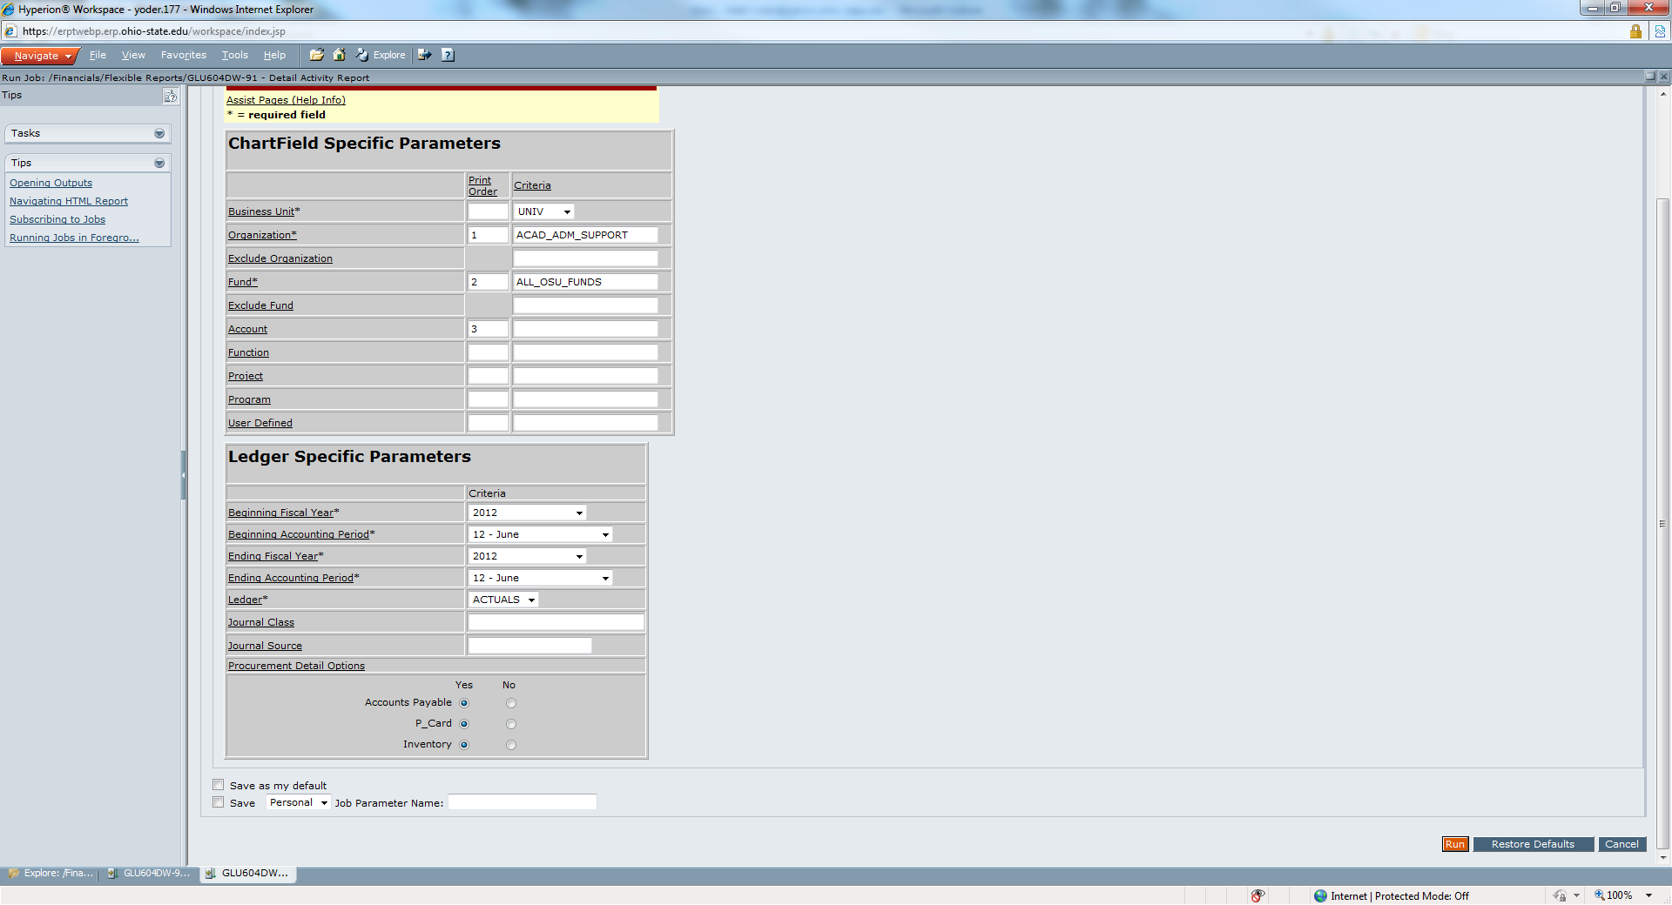Click Run to begin the Query
5. A Hyperion Workspace Question box will open, click “OK”
6. 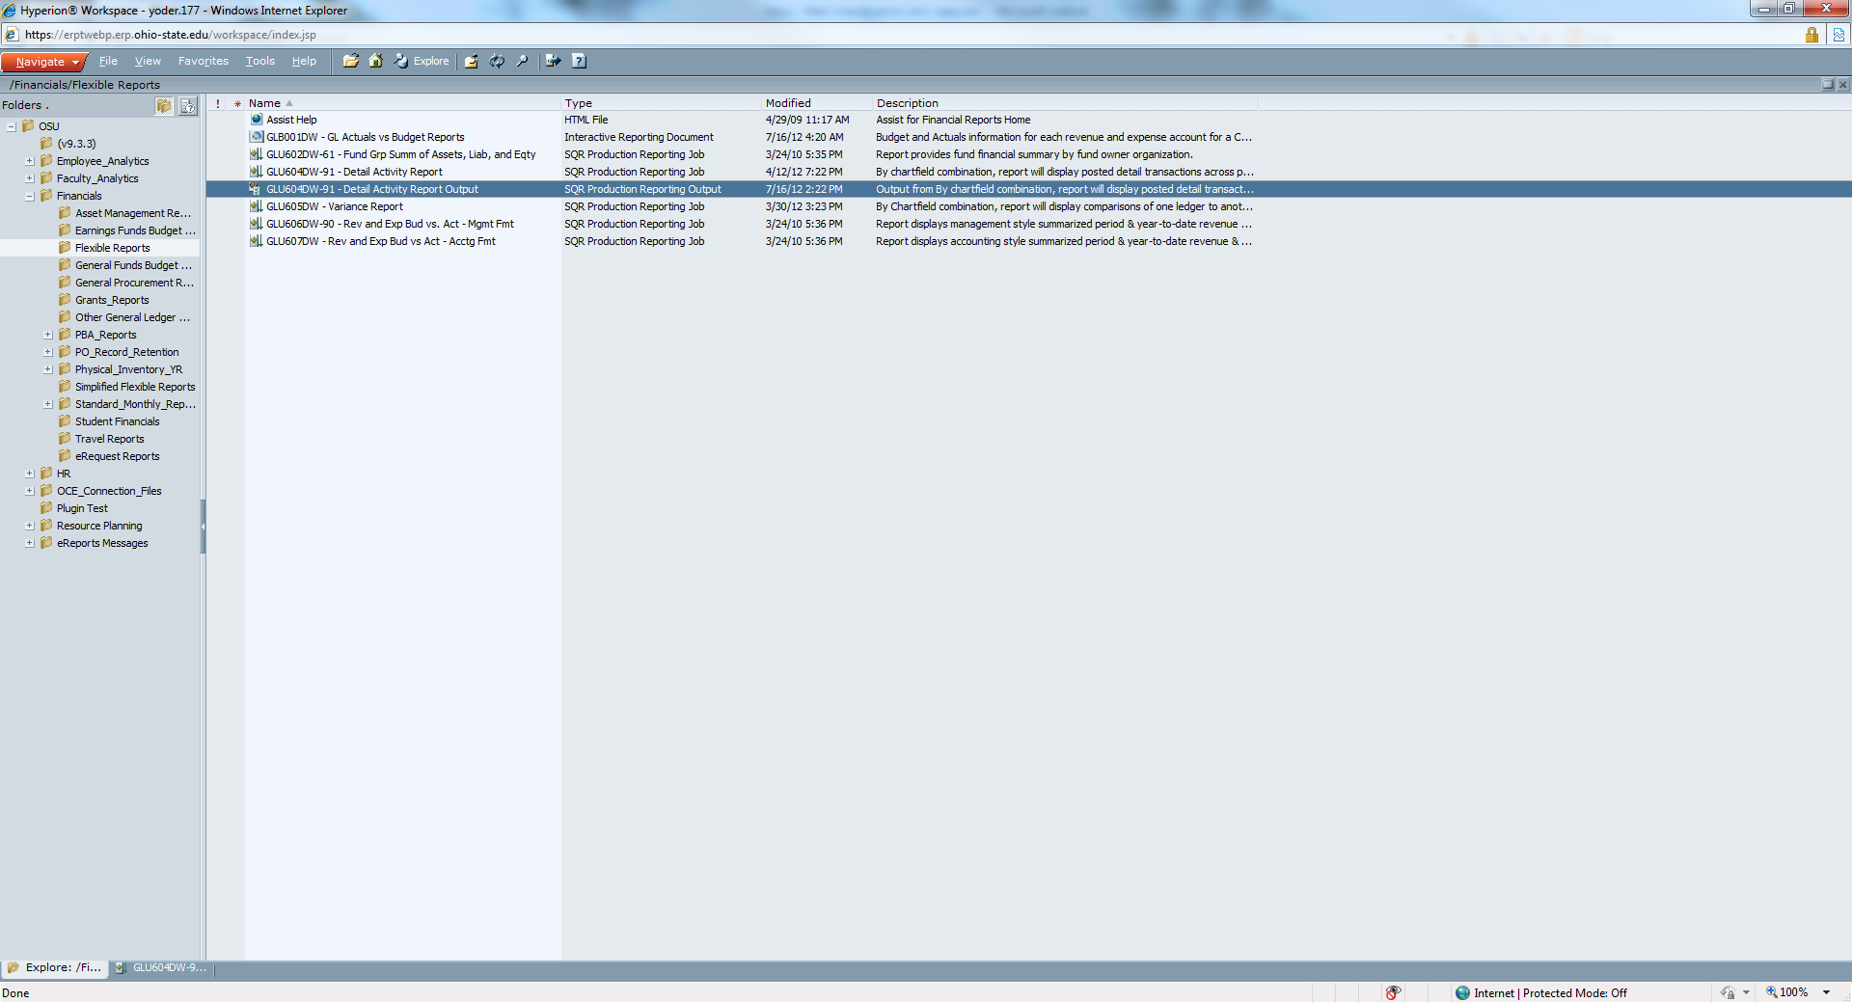The Flexible Reports home screen box will appear again. This query will run in the background and will not display a status box nor will it alert when it had completed. In order to refresh the screen and show the completed query, click F5 until the completed query appears on the homepage. Double click the selected query results
7. 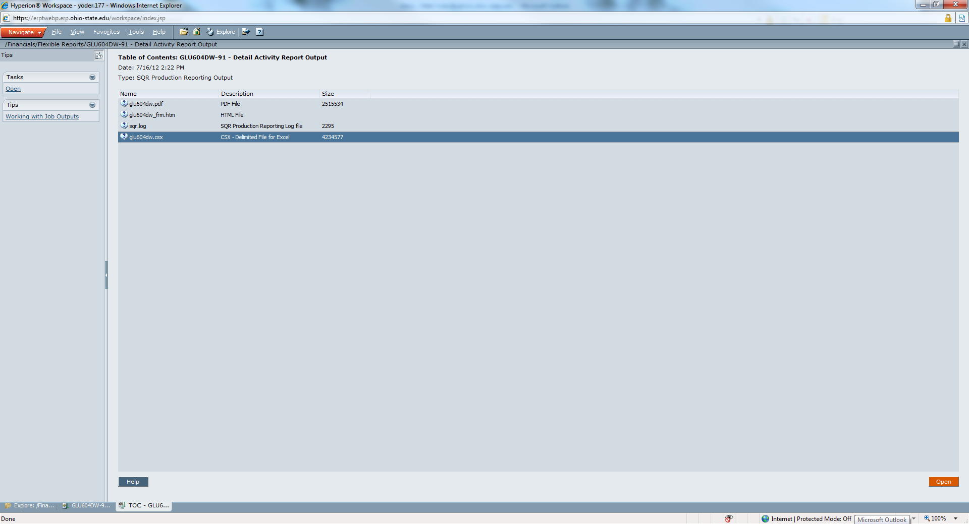The data is presented in four formats: PDF, HTML, SQR Log File and Excel CSX. In order to manipulate the data in Excel, select the CSX file
8. 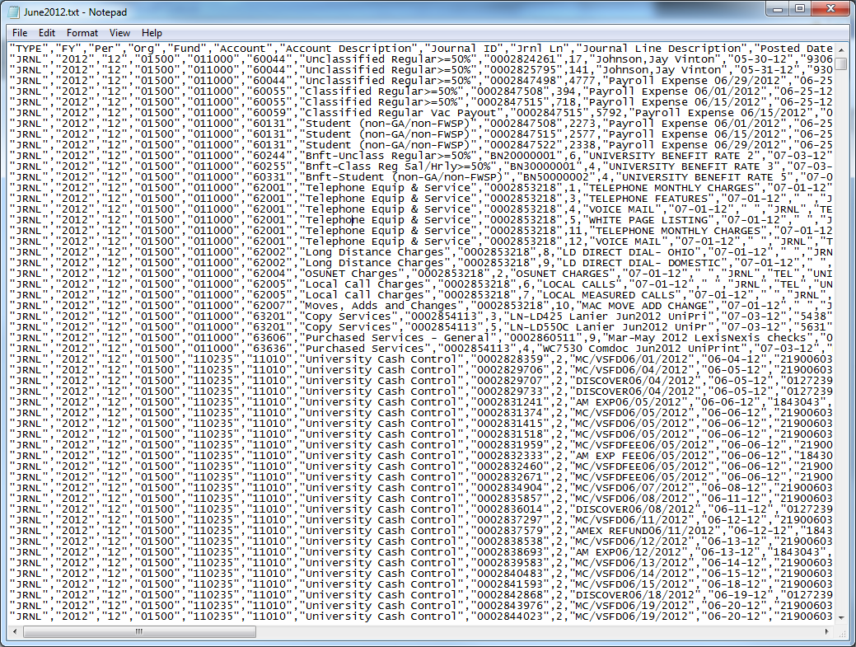A File Download box will appear asking whether or not the file needs to be Opened or Saved. Click Open and a Microsoft Word file will appear. Open a new WordPad document and copy and paste the information in the Word document to the WordPad document. Save the file at the following path: OAA_Bricker -> OAA_FiscalHR_Students -> OAA Service Center – Data -> Monthly Text Files

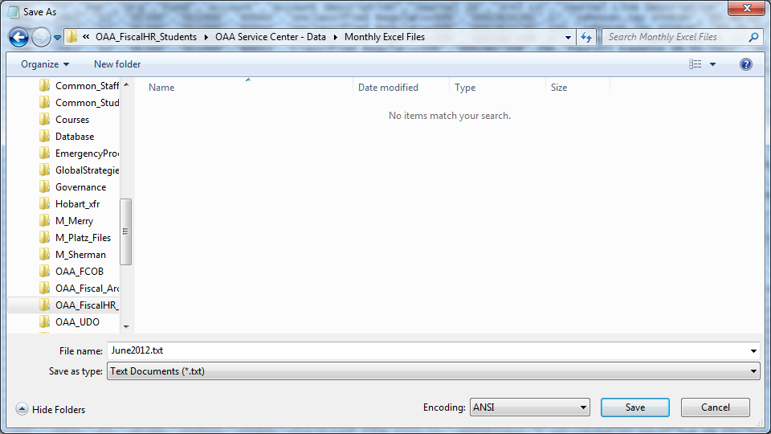

1. 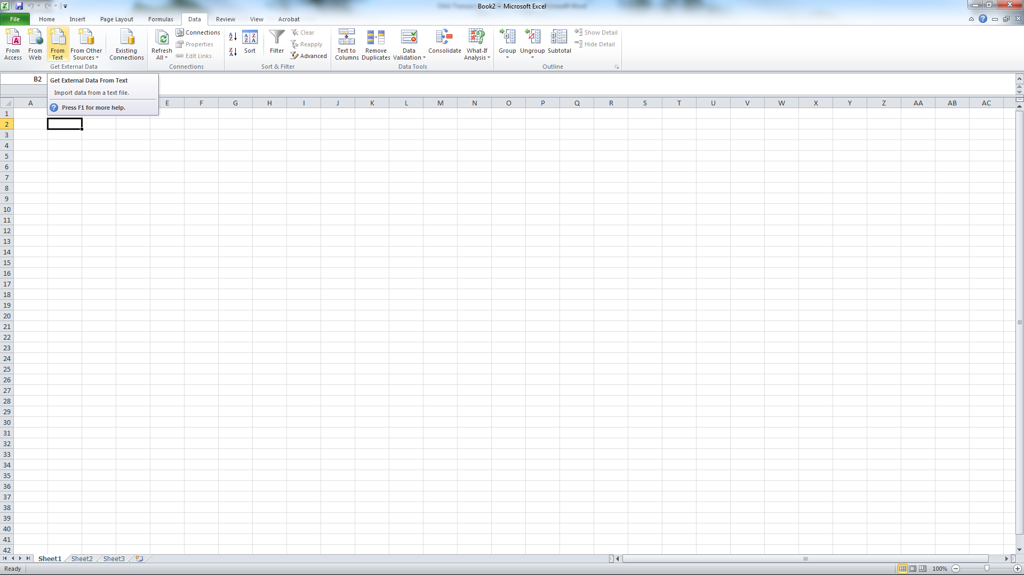Open a new Microsoft Excel document and under the Data tab, select From Text from the Get External Data section and select the file saved above
2. Follow the Text Import Wizard through all three steps with the following commands:
   1. Step 1: Select Delimited and make sure the Start import row is set at 1
   2. Step 2: Make sure comma is selected under the delimiters section
   3. Step 3: Change the following columns to Text format: Per, Org, Fund and Journal ID
   4. Click Finish and a second box will pop up asking where to put the data. Make sure A1 is selected
3. Save this Excel document at the same path listed above but in the Monthly Excel Files folder

**Process #2: Sample selection of the Transactions**

Once the data has been downloaded from eReports, the transactions are sent to Institutional and Research Planning in order to obtain a smaller sample of the downloaded monthly transactions.

1. Open the saved Excel document from Process #1
2. Add the additional columns to this document explained in Appendix 1.1
3. Right click on the data tab and make a copy of the tab within this same worksheet. Name the copied tab Raw Data – Unique and name the original Raw Data
4. On the Raw Data – Unique tab, sort all values by the Amount column
5. Once sorted, delete all line items that have blanks or null values for the “Amount”. These transactions are being removed in order to provide a unique posting count as some postings contain multiple transactions which show up multiple times in the data. These items are being temporarily removed in order to avoid duplicate values
6. Insert a pivot table from the Insert tab in Excel
7. Drag Transaction Description under the row labels section in the pivot table options, OSU Unit under the Column labels and Type under the Values (ensure Type is being counted and not summed)
8. Hide the Raw Data tab and save the document
9. Remove the following transactions prior to submission:
   1. Cash Advance (OSP - any transactions for the Office of Research that have an Org of 40209 as well as an Org of 40200 with a Fund of 011500 and an Account of 64615 and any transactions which has “Hay” as an Account Description – these items are already reviewed by OSP and will not be included in this sample
   2. Deposits – any transactions that have an Account Description of University Cash Control as these transactions are system offsetting items of the actual deposits
   3. Delete all transaction types on page 15 that have “Will not be Documented”
10. Due to coding, some of the transactions types may not accurately depict the correct transaction description. Prior to submitting the data for sampling, follow the steps listed on page 1.2 of the appendix
11. Email this document to Jason Sullivan at the Institutional and Research Planning and CC Gretchen Gombos

**Process #3: Load Sample Transactions into Access Database**

Once the data has been put into a smaller sample size, the sample data will be uploaded into an Access database where the information will be reviewed and documented. Prior to importing the document into access, the following columns need to be added into the excel document:

1. Columns to be Updated:
   1. POID – If the transactions have a sub-line items on the master raw file, the Purchase order ID will be imported into this field
   2. TNumber – If the transactions have a sub-line items on the master raw file, the Travel Number will be imported into this field
   3. VNumber – If the transactions have a sub-line items on the master raw file, the Voucher Number will be imported into this field
   4. InvoiceID – If the transactions have a sub-line items on the master raw file, the Invoice ID will be imported into this field
2. Columns to be left blank (these columns will be left blank during import):
   1. Comments:
   2. Approval
   3. Dollar Amount
   4. Chartfield
   5. Documentation
   6. Compliance
   7. Attachment Comments
   8. Pass?
   9. Failed Unit/SC
   10. Primary/Secondary
   11. Processor

Once these updates have been completed, this sample file will be saved at the location below and will be named as the proper year and month followed by the word “Load”. For example, for July 2012 sample data, the file will be named “2012.07.Load”.

OAA_Bricker (W:) -> OAA_FiscalHR_Students -> OAA Service Center – Data -> Monthly Excel Files -> Load Files

After the document has been saved, the following steps will be taken to load the document into Access:

1. Once the database is open, click External Data
2. Above Import & Link, click Excel
3. Click browse and use the file path listed above to find the Load document previously saved above. Make sure “Import the source data into a new table in the current database” is selected and click Ok.
4. A security notice may appear, if so click Open
5. On the first prompt, click the check box next to “First Row Contains Column Headings” and then click Next
6. On the next two prompts, click Next
7. On the final prompt, change the name of the table. Use the same name listed above when previously saved as an Excel document. For our example, the document will be named 201207Load and click Finish
8. The excel document will now be listed as a Table under the Access Objects column on the left side

After the file has been loaded, an additional column will need to be added prior to linking to the Verification Home Page. Below are the steps to update:

1. Double click the newly created table that was just imported (in this example, 201207Load”
2. Scroll to the last column on the document where it says “Click to Add”. Left click and select “Attachment”
3. Once added, save the table and close

The final step to loading the sample data is to ensure the Verification Home Page is referencing the new table. In order to do this, follow these steps:

1. Under the All Access Objects column on the left side, right click on the Form listed and select Design View (in this example, the Form is named “JulyReview”). Below is a screen shot of the location of the form:

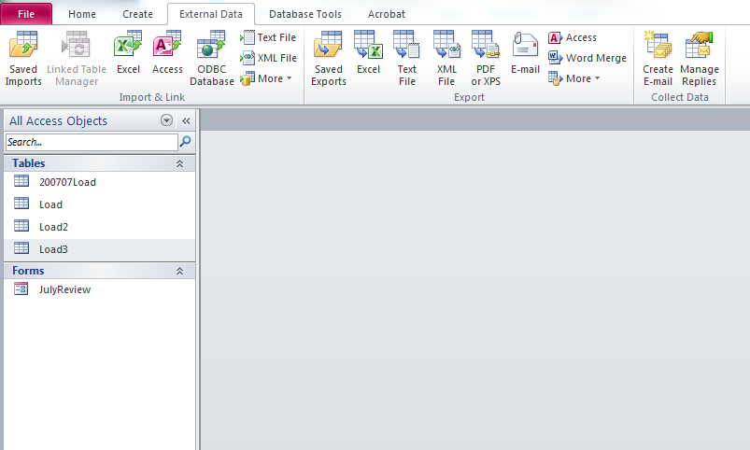

1. Once the form is opened in Design View, ensure that the Property Sheet is open on the right side of the screen. If it is not, on the Design Tab, click Property Sheet above Tools
2. On the Property Sheet column, click the Data tab
3. On the top drop down, make sure Form is selected. On the Record Source dropdown, check and see if the dropdown says the name of your imported table (this example would say 201207Load). If not, click the dropdown arrow and select that table.
4. Once changed, save the Form and close it

Once these steps have been completed, the Verification Home Page can be used to interact and verify the transactions. Below is a screen shot of what the home page will look like:

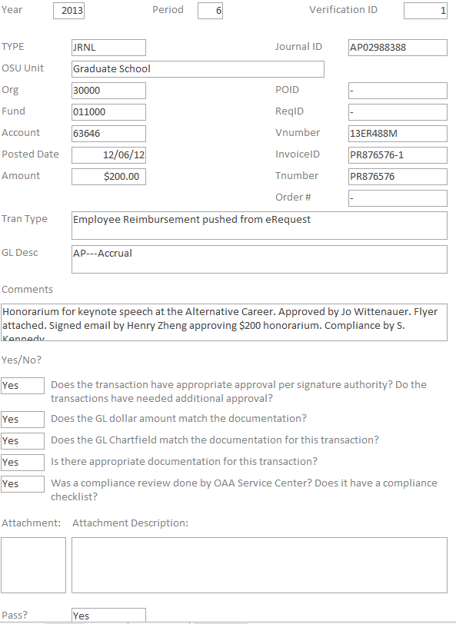

**Process #4 and #5: Obtain Needed Backup Documentation and Perform Transaction Verification Process**

The following chart shows all transaction types found within the transaction data:



**Workflows:**



**Workflows Continued:**



**Workflows Continued:**



**Workflows Continued:**



**Workflows Continued:**



**Workflows Continued:**



**Workflows Continued:**



**Workflows Continued:**



**Workflows Continued:**



**Workflows Continued:**



**Workflows Continued:**



**Workflows Continued:**



**Workflows Continued:**



**Workflows Continued:**



**Workflows Continued:**



**Workflows Continued:**



**Workflows Continued:**



**Workflows Continued:**



**Workflows Continued:**



**Workflows Continued:**



**Workflows Continued:**



**Workflows Continued:**



**Required Documentation for Transaction Verification:**

Paper and electronic documentation to backup each of the selected transactions will not be printed during this process. The backup documentation resides in multiple University systems and University archives and will not be required to keep another copy for audit purposes. Since this information will remain available on University servers for more than five years and since the paper copies will be kept on site, it will not be required to have this documentation saved with this access database. If copies are needed for audit purposes or other reasons, please refer to the workflows above in order to pull the necessary documentation.

**Process #6: Record Findings and Conduct Follow Ups with Units and Service Center for Failed Transactions**

The Data Manager will complete the Transaction Verification process and will record all findings within the access database. During this process, if a transaction does not meet the five requirements listed on page 3 and 4 of this document, the Data Manager will proceed with the Follow Up process listed below:

Follow Up on Failed Transactions:

1. Determine whether the error was a result of the Service Center or the Unit. Once the source of the error is determined, the Data Manager will reach out to the following contacts:



1. Data Manager will follow up via email with each contact for each failed transaction type. The following information must be addressed:
   1. The issue with the transaction
   2. Possible cause for the error
   3. Resolution to ensure the error is corrected for future transactions
2. Failed Transaction Type and responsible Unit will be added to the next month’s Review List
3. Once issue has been addressed, upload email into access database

**Process #7: Final Review and Fiscal Manager and AVP Approval**

Once all the transactions have been reviewed and all failed transactions have been followed up on, a summary report will be generated that will summarize the overall performance of the transactions. The report will state how many transactions from each sample population there were and what the pass percentage is. This report will then be reviewed by the Fiscal Manager and Assistant Vice President of the Office of Academic Affairs. Below is a sample of the approval sheet:



**Timing and Completion for Transaction Verification**

The Transaction Verification process will follow similar timing guidelines as the reconciliation process. Listed below are the expectations for process and completion of a specific month when operating in a business as normal process:

1. On the 5th business day of a specific month, the prior months data will be pulled from a flexible 91 report in order for the Verification process to begin
2. The data pulled from the Flexible 91 report will be reviewed and summarized within one business day and sent to Institutional Research and Planning
3. Institutional Research and Planning will review, analyze and sample the data and return the Verification sample no later than the 15th of the current month
4. The Verification team will have the remaining part of the month to review, follow up and complete each transaction by the end of the current month
5. In the event that a transaction needs additional information or documentation from a Unit, the Verification team will reach out to the Unit through a single email request giving the Unit one to two weeks’ time in order to respond with the needed information
6. In the event that a transaction needs additional information or documentation from the Service Center, the Verification team will reach out to the Service Center through email requesting the documentation be sent with one to five business days
7. The Verification team has 30 days to complete the verification process once the data has been received
8. Once all documents have been received and transactions have been verified, the Data and Quality Manager will have one business day to compile the printed results and have the Fiscal Manager and the Assistant Vice President sign off on the results
9. Results will be distributed to the Unit contacts along with the Service Center within one business day after signatures have been obtained

**Reporting for Transaction Verification**

**Reporting for Transaction Verification continued**

**Appendix 1.1: Additional Data Columns for Monthly Transactions**

This appendix will explain how to add the proper Unit, Voucher Code and Transaction Description to each transaction downloaded from eReports

Unit:

1. In cell AL1, type “OSU Unit”
2. In cell AL2, enter the following formula:  
    =VLOOKUP(D7,'W:\OAA_FiscalHR_Students\OAA Service Center - Data\Lookups\[UnitLookup.xlsx]Unit Lookup'!$A$2:$E$601,4,FALSE)
3. Drag the formula in this cell down to the last transaction on the Excel document

Voucher Code:

1. In cell AM1, type “Voucher ID”
2. In cell AM2, enter the following formula:  
   =LEFT(MID(AA2,3,3))&LEFT(MID(AA2,3,4))
3. Drag the formula in this cell down to the last transaction on the Excel document

Transaction Description:

1. In cell AN1, type “Combined”
2. In cell AN2, enter the following formula:  
   =M2&N2&AM2&G2
3. Drag the formula in this cell down to the last transaction on the Excel document
4. In cell AO1, type “Transaction Description”
5. In cell AO2, enter the following formula:  
   =VLOOKUP(AN2,[DescriptionLookup.xlsx]Description!$E$2:$F$2296,2,FALSE)
6. Drag the formula in this cell down to the last transaction on the Excel document
7. Review all of the lookup functions calculated in the above steps. If any of the formulas return #N/A, that means that either the Unit or Transaction Description are new and need to be added to the lookup spreadsheets
8. Once all formulas are completed, highlight columns AL through AO. Copy and paste special values in these columns
9. Hide column AN

Survey Data:

1. In Cell AP1, type “Combined2”
2. In cell AP2, enter the following formula:

=AL2&AO2

1. Drag the formula in this cell down to the last transactions on the Excel document
2. In cell AQ1, type “Rate of Error”
3. In cell AQ2, enter the following formula:

=VLOOKUP($AP2,'W:\OAA_FiscalHR_Students\OAA Service Center - Data\Lookups\[SurveyLookup.xlsx]Raw'!$C$2:$G$397,2,FALSE)

1. In cell AR1, type “# of Touch Points”
2. In cell AR2, enter the following formula:

=VLOOKUP($AP2,'W:\OAA_FiscalHR_Students\OAA Service Center - Data\Lookups\[SurveyLookup.xlsx]Raw'!$C$2:$G$397,4,FALSE)

1. In cell AS1, type “Compliance/Fraud Risk”
2. In cell AS2, enter the following formula:

=VLOOKUP($AP2,'W:\OAA_FiscalHR_Students\OAA Service Center - Data\Lookups\[SurveyLookup.xlsx]Raw'!$C$2:$G$397,5,FALSE)

1. Drag the formulas in the previously mentioned three columns to the last transaction on the excel document

**Appendix 1.2: Correcting Mislabeled Transaction Types:**

Based on coding, some transaction types show up incorrectly when the Transaction Type is assigned to each line item. This issue is directly related to the Req, PO, Special Convenience Order Numbers with Paper Request description type but is also related to a few other categories such as Individual Gifts to Principal Fund and Journals. In order to correct these types, follow the instructions below:

1. Open the current month raw data tab and sort the data based on “Amount”
2. Copy all line items which do not have a dollar value and paste into a new spreadsheet and name this new spreadsheet “Blank Amounts”
3. Insert a new column between “Voucher ID” and “Transaction Description” and name this column “Comb”
4. In the “Comb” column, enter the following formula in the 1st cell of that column:
   1. =D2&E2&F2&G2&H2&I2
5. Open the current month filtered file and insert two new columns between “Voucher ID” and “Transaction Description”. Name the first column “Comb” and the second “New Transaction Type”
6. Complete the same process listed in step 4 for the “Comb” column
7. In the first cell of the “New Transaction Type” column, complete a vlookup that pulls the “Comb” column value from the Filtered file and looks up the Transaction Type from the “Blank Amount” file
8. Where there are #N/A values in the “New Transaction Type” column, use the original Transaction Type
9. Copy and paste all new values from the lookup function for the Req, PO, Special Convenience Order Numbers with Paper Request in the original Transaction Type column
10. Review any other variances listed between the two Transaction Type columns to determine if other values need to be changed according to the type of transaction

**Appendix 1.3: Necessary System Access:**

In order to complete the Transactions Verification process, a processor must have access to the following systems:

1. PeopleSoft – HR
2. PeopleSoft – Financial
3. The Advancement System (TAS)
4. Mail Website (receivingandmail.osu.edu)
5. eReports – HR
6. eReports – Financial
7. HR Action
8. eTravel
9. UNITS Website
10. OAA Bricker Shared Drive (W:)

System access can be limited to read-only for each of these systems as no processing is necessary during the Transaction Verification.