College of Nursing

364 Newton Hall
295 W 10th Ave
Columbus, OH 43210

Phone (614) 292-8900
Fax (614) 292-4535
Web nursing.osu.edu



July 20, 2026

Dr. W. Randy Smith, Vice Provost for Academic Affairs
Office of Academic Affairs
University Square South
Columbus, OH 43210

Dear Dr. Smith,

The College of Nursing is requesting Council on Academic Affairs approval for the deactivation of the Bachelor of Science in Health and Wellness (BSHW). Low enrollment is the reason for proposed deactivation, as stipulated by SB1. There are currently 2 students in the program and will be supported in their completion of the degree. This includes two students who are anticipated to graduate in spring 2027 and will be allowed to complete the program.

Please let me know if any additional information is needed in support of this request.

Sincerely,
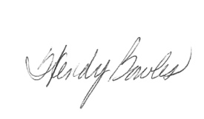
Wendy Bowles PhD, APRN-CNP, CNE
Associate Clinical Professor
Associate Dean for Baccalaureate Programs
Pediatric Nurse Practitioner
College of Nursing
364 Newton Hall, 295 W. 10th Ave., Columbus, OH 43210
614-292-4928 Office
bowles.107@osu.edu

