
Office of the Dean Team
200 Fisher Hall
2100 Neil Avenue
Columbus, OH 43210-1144
614-292-6610 Phone
fisher.osu.edu

December 12. 2025

To: Randy Smith, Vice Provost, Office of Academic Affairs
From: Keely Croxton, Associate Dean of Undergraduate Programs, Fisher
Re: INFORMATIONAL ITEM – Fisher College of Business, Strategic Sales Certificate Update

Dear Randy:

In order to fix an error in our original proposal, we would like to change Fisher’s Strategic Sales Certificate from a standalone certificate to an embedded one. Our intentions are for this certificate to be only available to degree-seeking OSU students, not to the broader non-student community.

Please let me know if you need any other information.

Sincerely,

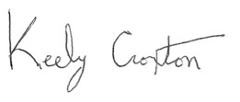
Keely Croxton, PhD
Associate Dean of Undergraduate Programs and Global Engagement
Fisher College of Business
The Ohio State University

