2012-2014 Report to CAA from ULAC

Summary
The University-Level Advisory Committee (ULAC) for the General Education program at the Ohio State University, a subcommittee of the Council on Academic Affairs (CAA), is charged with providing an annual report and recommendations to CAA on the status of the General Education (GE) program, making recommendations with respect to the GE as appropriate, and monitoring the national dialogue on general education.
In 2012-14, ULAC considered issues related to semester conversion, including a review of changes in the GE relative to the GEC-R, reviewed university-wide assessment data, consulted with the Arts and Sciences Curriculum Committee Assessment Panel on issues relating to GE outcomes assessment, and studied recent findings with respect to general education high-impact practices and outcomes assessment.
Overall, the quarter to semester transition went remarkably smoothly. ULAC has a number of recommendations regarding the student curricular experience and GE outcomes assessment, including:
- Explore technological solutions for GE outcomes assessment
- Involve students and academic advisors in collecting university-wide evidence of student learning
- Expand the use of rubrics in GE outcomes assessment
- Support institutional efforts to increase student participation in high-impact educational practices
- Continue annual data collection to monitor GE course offering and student enrollment patterns
- Continue efforts to communicate GE learning outcomes and approval processes to the University community

State of the general education program

GE vs GEC-R comparisons:
The framework for the semester-based general education requirements (GE) was developed by ULAC in 2009-10 in the context of a formal statement about the curricular experience at Ohio State (Appendix 2). The semester-based GE requirements (see Appendix 3 for their implementation in the College of Arts and Sciences) are presented as a topical list that is generally based on the categories present in the quarter-based general education curriculum as revised for students entering the University in 2008 (the GEC-R). A number of significant differences between the GE and GEC-R are summarized below and should be monitored with respect to their potential impacts on the undergraduate experience at Ohio State.

GEC-R requirements that no longer exist as separate requirements
The third writing course required in the GEC-R was approved within the major for some majors, but was not universally implemented. This requirement has been dropped in the GE, with the consequence that all students are now required to take two semesters of writing (Writing Level 1 and Writing Level 2, 6 semester credits) in place of two or, in some cases, three quarters of coursework (First, Second, and Third Writing courses; 10-15 quarter credit hours). The consequences of this change are complex: many students will spend a longer time engaged in the study of writing and related skills (two semesters rather than two quarters), although the number of contact hours will not change significantly; other students (if their majors dropped the third writing requirement in converting to semesters) may see a reduction in the amount of time and depth in their study of writing and related skills.
The Issues of the Contemporary World (Capstone) category in the GEC-R BA requirements is no longer a separate requirement in the GE. The former capstone courses are now counted as cross-disciplinary seminars in the Open Option of the GE (see below).

Open Option in the GE
The “Additional Breadth” area of the GEC-R allowed students to take additional coursework in any “breadth” category of the GEC; this concept has been significantly expanded in the “Open Option” of the GE requirements, allowing students more flexibility to complete GE requirements and supporting students who engage in high-impact curricular experiences. Under the Open Option, students may count courses in any of the GE categories, or any approved service learning course, education abroad course, or cross-disciplinary seminar (including the former capstone courses). As was the case with the Additional Breadth category of the GEC-R (per the 2010-11 ULAC draft report), it is likely that many students, rather than taking full advantage of the flexibility offered within the Open Option, are fulfilling this requirement with courses that are prerequisites for their major or are closely related to their major area of study.
ULAC recommends further study of the Open Option and how it is actually being implemented in students’ programs of study. It is difficult to use the current degree audit system to tease out student intentions with respect to satisfying GE requirements. ULAC recommends further study of this curricular option through consultation with students and academic advisors, and continued monitoring of enrollments in the Open Option-approved service learning and education abroad courses, and in cross-disciplinary seminars (see Appendix 4 – because there were no approved service-learning courses yet in 2012-13, no enrollment data are presented for those courses).

Modified GE categories
The science requirement in the GE has changed somewhat with respect to the GEC-R: the number of courses required is (nominally) lower, and the requirement for a two-course sequence has been dropped. The semester-based GE for B.A. programs requires a minimum of 10 credit hours of science coursework, including at least one course in the biological sciences and one in the physical sciences, and at least one course with a laboratory. In comparison, in the GEC-R, BA students were required to take three quarters of natural sciences: one two-quarter sequence in the biological or physical sciences and a third course in the area not covered, with at least one of the three including a lab. The net effect of the changes in the science category of the GE for students seeking a BA is likely to be increased flexibility, but with no net change in the number of courses or labs taken to satisfy the requirement (students are likely to take three one-semester courses in place of the previous three-quarter requirement).
The semester-based GE for B.S. programs likewise requires a minimum of 10 credit hours of science coursework, including at least one course in the biological sciences and one in the physical sciences; however the B.S. requires two labs, one in each area of the sciences. In the GEC-R, BS students were required to take four quarters (20 credit hours) of natural sciences: one two-quarter sequence in the biological or physical sciences and two additional courses, with at least one in the area not covered by the sequence, and with at least one of the four courses including a lab. The GE science requirement for B.S. students is simplified, and represents a nominal reduction in the number of courses and credit hours needed to satisfy the science requirement.
Finally, as is evident above, the GE science requirement is stated in terms of both courses and credit hours, with ramifications that may not be readily apparent to students. ULAC recommended that documents describing the GE science requirement should clarify this requirement so that it is readily apparent to students that they may need to take three or more courses and/or they may exceed 10 credit hours in satisfying this requirement.
The Cultures and Ideas category of the GEC-R has also changed somewhat under the semester-based GE. Many Cultures and Ideas courses can satisfy Social Diversity in the United States or Global Studies requirements in the GE, but these latter requirements are intended to overlap with another GE category. In the GEC-R, most Cultures and Ideas courses effectively could be counted only under the Additional Breadth category. In the GE, courses in this category can be used as Open Option courses or in place of a second Historical Study course.
Finally, the Historical Study requirement under the GE is somewhat reduced, with only one course formally required under the GE, where two were required in the GEC-R.

Global Studies
The Global Studies category of the GE replaces two categories (International Issues: Western, non-US, and International Issues: non-Western or Global) in the GEC-R. Merging the Western and non-Western or Global distinctions is likely to be less confusing to students, advisors, and faculty, and to better reflect the world in which we live. It is important to distinguish Global Studies and education abroad to avoid confusion when a course satisfies only one of these options.

College-level variability
While there is a common university-wide core within the GE program, some variability in implementation continues under semesters, similar to the variability in the GEC-R under quarters. For example, colleges outside the College of Arts and Sciences do not universally require foreign language proficiency. Generally, exceptions to the GE should be (and have been) justified either because they duplicate content in the major or because of other extenuating circumstances.

Variability in credit hours
Under the quarter system, almost all GEC-R courses were 5-credit courses. In part because of the modified definition of a semester credit hour, courses approved in the GE no longer adhere to a single credit hour norm. This has the effect of providing more options and generally greater flexibility for students. For example, to meet the 10-credit GE science requirement, students may take two 3-credit and one 4- credit course, or two 5-credit courses (depending on course availability).

Course offerings under semesters
The numbers of approved courses in the GE are compared with the last year of GEC-R courses under quarters in Appendix 5. Overall, the number of courses has not changed significantly, with the exception of Historical Study. The change in Historical Study course counting is largely an artifact of the way these courses were listed under quarters. Under the GEC-R, most courses offered by the Department of History could be counted as a second Historical Study course, but they were not officially designated GEC courses. Upon semester conversion, these courses became officially designated as GE courses, and can be used for the first or second Historical Study course.
In Appendix 6, the distribution of GE courses by college is provided. The majority of GE courses are still offered in the College of Arts and Sciences.

GE Course enrollments
Course enrollment data for the 2012-13 academic year are provided in Appendix 7. Because not all one-quarter courses were directly converted to one-semester courses, comparisons between the first year of semesters and previous years are difficult. It is clear that certain courses dominate certain categories of the GE, but that students have many additional choices as well as the lead courses in any one category. ULAC expect that these data will be collected every year for comparative purposes.

Data review
As part of this review, ULAC considered which data about GE courses and patterns of enrollment could be used systematically and should be collected every year (Appendices 4-8). The College of Arts and Sciences Curriculum and Assessment Services Office and the Office of Enrollment Services Analysis and Reporting were able to provide to the committee the data needed to evaluate GE course offerings. With 2012-13 being the first year of the transition to semesters and of the transition from GEC-R to GE requirements, retrospective comparisons of course offerings and enrollments were not undertaken. Trends in semester-based GE course enrollments will be evaluated in future years.
In addition, ULAC reviewed data obtained from the Collegiate Learning Assessment (CLA), National Survey of Student Engagement (NSSE), and the University’s pre-graduation undergraduate student survey. Data from these instruments were used previously to justify the inclusion of education abroad and service learning in the Open Option category of the GE. CLA data from 2009 freshmen and 2010 seniors showed gains in holistic measures of written communication, analytical reasoning and problem solving abilities. The skills assessed in the CLA align with several GE expected learning outcomes. GE-relevant NSSE data from 2004, 2007, and 2010 included strong positive student responses regarding the University’s contribution to their knowledge, skills and personal development in written communication, critical and analytical thinking, and in analyzing quantitative problems. Student responses regarding oral communication and solving complex real-world problems were a little lower, although the more recent survey years are increasingly positive. Data from the university-wide exit survey indicate that with respect to knowledge- and skills-related outcomes, 80% or more of students agreed they had attained the learning expected of Ohio State graduates. The data collected from these assessments is useful, but it is important to also obtain direct indicators of student learning. ULAC endorses efforts to employ standardized instruments, such as the Collegiate Learning Assessment Plus (CLA+), which uses performance tasks, for this purpose.

College of Arts and Sciences GE-related activities

GE course proposals approved:
Panels consisting of ASC Curriculum Committee (ASCCC) members and representatives of other colleges review new and existing courses that have been submitted for GE approval, and the panels make recommendations to the full ASCCC. Appendix 8 summarizes the numbers of GE courses reviewed by ASCCC in 2012-13. This rigorous process helps ensure the high quality of GE courses; however there are concerns that units outside the College of Arts and Sciences are not sufficiently aware of the process for submission of course proposals for GE status. ULAC recommends continued outreach efforts by the ASC Curriculum and Assessment Services Office to ensure that these processes are clearly and widely communicated.

Assessment
The Assessment Panel of ASCCC expanded its previous assessment plans to include additional emphasis on category-level assessment of GE learning outcomes. Rubrics are being used to assess GE learning outcomes in education abroad and service learning categories of the Open Options experiences. In addition, the Assessment Panel is working with a few departments that have large GE enrollments and a record of involvement in a particular category of the GE to develop rubrics that can be used to provide evidence about student learning in all courses within that category. The ASCCC Assessment Panel is also continuing to collect reports for many of the high-enrollment GE courses, including regional campus offerings.

ASC Curriculum and Assessment Services Office
The ASCCC and the ASC Curriculum and Assessment Services Office continue to publicize the expected learning outcomes of the GE. The ASC Curriculum and Assessment Services Office sends reminders to all course-offering units to include GE learning outcomes on course syllabi every time a GE course is offered.

National trends in GE
Nationally, there is a growing awareness that students will experience more flexibility in how they may earn college credits: for example, they may earn GE credits while in high school through advanced placement courses, international baccalaureate programs, dual enrollment courses taught at their high school that bear college credit, and/or dual enrollment at local colleges and universities. The increase in students bringing college credits with them upon matriculation at Ohio State highlights the need to reaffirm the value of the University’s curricular experience and the value of student interactions with university faculty. To this end, ULAC recommends enhanced communication about the value of the GE with faculty and students, as well as the larger community of parents and Ohio residents.
ULAC reviewed reports from the Association of American Colleges and Universities (AAC&U) about the value of so-called” high-impact” educational activities (as defined by George D. Kuh for the AAC&U: first-year seminars and experiences, common intellectual experiences, writing-intensive courses, collaborative assignments and projects, undergraduate research, diversity/global learning, service and community-based learning, internships and capstone courses and projects). NSSE survey data (Appendix 9) about these high-impact practices were shared with the curricular Deans, who joined ULAC in requesting more data about the implementation of these high-impact practices across the university, including demographic data about student participation. Some of these educational activities are already widely implemented, and the new STEP (second-year transformational experience program) will facilitate student consideration of and engagement in several of these high-impact educational practices.
The AAC&U has spearheaded the development of rubrics (LEAP rubrics, available at the AAC&U web site) that can be used to measure student achievement of learning objectives that are widely held to be desirable outcomes of higher education. ULAC has examined these rubrics, and endorses the idea of using similar rubrics to assess GE learning objectives.

Next steps for ULAC

Explore technological solutions for GE outcomes assessment
There are potentially large amounts of data about student curricular experiences (e.g. tracking student performance from one course to the next) and student learning (e.g. student writing in courses other than GE writing courses) that cannot easily be collected and used to evaluate the GE because of technology limitations. In addition, there are sources of data that go untapped (e.g. in some colleges, student outcomes after they graduate from Ohio State). Ideally, better coordination between different offices (e.g. departments, Career Services, the OSU Alumni Organization), and better use of data analytics could dramatically improve our ability to understand how students learn during their undergraduate experience at Ohio State.
Furthermore, once rubrics are available for specific categories of the GE (see below), it would be useful to integrate them into our course management system, Carmen, so that instructors can utilize the rubric when evaluating assignments that address GE learning objectives. The data could then be collected from the Carmen sites for all GE courses, allowing efficient reporting of GE outcomes data.

Involve students and academic advisors in collecting university-wide evidence of student learning
ULAC recommends formation of a student advisory group that can help develop strategies for GE outcomes assessment, disseminate information about the GE, and implement plans for GE improvements. Such a student advisory group can serve as a rich source of information about how students navigate the GE and through their own participation in assessment efforts, about student learning.
In many ways, advisors are the face of the GE, in that they explain the GE principles and rationale to students, they assist with GE course selection, and they help students build a cohesive curriculum that achieves the goals of the OSU Curricular Experience. In 2009, ULAC conducted a focus group to obtain information from advisors about how students were navigating the (Au 2007) revised GEC. At that time, advisors noted that the greater flexibility in the revised GEC seemed to be working well, but that there was a need for better communication about college-specific requirements and new GEC course approvals, among other things. In 2011-12, ULAC’s GE framework for semester conversion included specific recommendations supporting advising flexibility during the quarter-to-semester transition. Now that students and advisors are settling into semesters and many of the transition issues are behind us, ULAC would like to revisit issues raised earlier by advisors and to determine whether there are semester-specific advising concerns that need to be addressed. To this end, ULAC will conduct focus groups and/or surveys with advisors from different colleges across the University and develop a plan to improve communications regarding the GE, find out more about how the Open Option is used, and tackle any other issues raised.

Expand the use of rubrics in GE outcomes assessment
The ASCCC Assessment Panel has modified its previous GE assessment plan to include rubric-based assessment at the category level. Faculty teaching courses in the Education Abroad and Service Learning categories of the Open Option are now using a common scoring rubric to evaluate student achievement of GE expected learning outcomes, providing a consistent set of data that is then reviewed by the Assessment Panel. Additional rubrics are in various stages of development for use in additional GE categories (not just in the Open Option).

Support institutional efforts to increase student participation in high-impact educational practices
ULAC recommends that colleges and departments be surveyed to determine the extent of student participation in high-impact educational practices, and encouraged to expand student participation in these practices, which include first-year seminars and experiences, common intellectual experiences, writing-intensive courses, collaborative assignments and projects, undergraduate research, diversity/global learning, service and community-based learning, internships and capstone courses and projects.

Continue annual data collection to monitor GE course offering and student enrollment patterns
Reports should include information about trends in GE courses such as numbers of courses offered by category, enrollments categorized by course, section, category, and offering unit, and numbers of courses offered by the College of Arts and Sciences and other colleges. Student enrollment patterns in the Open Option areas should be monitored. To the extent possible, data should also be collected to evaluate whether students take advantage of changes in the GE to maintain breadth or increase concentrations (e.g., by pursuing more minors or double majors).

Continue efforts to communicate GE learning outcomes and approval processes to the University community
To help clarify how the GE has been implemented in different colleges, ULAC recommends the development of college-specific GE templates. Adaptation and implementation of the GE varies within different colleges at the University. The rationales for these variations seem reasonable, given the educational objectives of different programs at Ohio State. To help us evaluate the potential impact of variations in the GE on the student experience, and to help students understand the differences among programs, a series of GE templates for each college in a standardized format is needed.

Appendices
We gratefully acknowledge the support and data collection efforts of the College of Arts and Sciences Curriculum and Assessment Services Office, especially Danielle Hogle, and those of the Office of Enrollment Services Analysis and Reporting, especially Linda Katunich.
- 2012 and 2013 ULAC membership
- Curricular experience statement
- Arts and Sciences GE template
- Education Abroad approved courses and enrollment numbers; interdisciplinary seminars and enrollment numbers
- Quarter and Semester Course Counts
- GE courses by college
- Course enrollments by GE category
- Course proposal statistics from Arts and Sciences Curriculum and Assessment Services Office
- NSSE data

Appendix 1.
2012 and 2013 ULAC membership

Caroline A. Breitenberger, Chair
University-level Advisory Committee for General Education (ULAC-GE)
Membership for 2012-13
Director, Center for Life Science Education
College of Arts and Sciences
260P Jennings Hall
1735 Neil Avenue
614-292-6945
breitenberger.1@osu.edu

Jane D. Case-Smith
Professor
School of Health and Rehabilitation Sciences
College of Medicine
406 Atwell Hall
453 West Tenth Avenue
614-292-0357
case-smith.1@osu.edu

Mary Jo Fresch
Professor
College of Education and Human Ecology
Marion Campus
Morrill Hall
1465 Mount Vernon Avenue
Marion, OH 43302
740-389-6786
fresch.1@osu.edu

Jacqueline J. Gargus
Associate Professor
Knowlton School of Architecture
College of Engineering
226 Knowlton Hall
275 West Woodruff Avenue
614-292-9850
gargus.1@osu.edul

Kenneth W. Goings
Professor
Department of African Amer & African Studies
College of Arts and Sciences
486 University Hall
230 North Oval Mall
614-292-0237
goings.14@osu.edu

Rebecca C. Harvey
Professor
Department of Art
College of Arts and Sciences
258 Hopkins Hall
128 North Oval Mall
614-292-5072

Mary Ellen Jenkins, Ex officio
Assistant Executive Dean
ASC Advising/Academic Services
151 Denney Hall
164 West Seventeenth Avenue
614-292-7272
jenkins.196@osu.edu

Courtney S. Kasuboski
Undergraduate Student Government
College of Engineering
kasuboski.1@osu.edu

Lawrence A. Krissek
Professor
School of Earth Sciences
College of Arts and Sciences
215 Orton Hall
155 South Oval Mall
614-292-1924
krissek.1@osu.edu

Moriah E. Locklear
Undergraduate Student Government
College of Pharmacy
locklear.15@osu.edu

Thomas A. Schwartz
Associate Professor
School of Communication
College of Arts and Sciences
3074 Derby Hall
154 North Oval Mall
614-292-1006
schwartz.13@osu.edu

W. Randy Smith, Ex officio
Vice Provost, Academic Programs
Office of Academic Affairs
203 Bricker Hall
190 North Oval Mall
614-292-5881
smith.70@osu.edu

Patricia M. West
Associate Professor
Fisher College of Business
544 Fisher Hall
2100 Neil Ave
614-292-0568
west.284@osu.edu

harvey.113@osu.edu
Caroline A. Breitenberger, Chair
University-level Advisory Committee for General Education (ULAC-GE)
Membership for 2013-2014
Director, Center for Life Science Education
College of Arts and Sciences
260P Jennings Hall
1735 Neil Avenue
614-292-6945
breitenberger.1@osu.edu

Jane D. Case-Smith
Professor
School of Health and Rehabilitation Sciences
College of Medicine
406 Atwell Hall
453 West Tenth Avenue
614-292-0357
case-smith.1@osu.edu

Jacqueline J. Gargus
Associate Professor
Knowlton School of Architecture
College of Engineering
226 Knowlton Hall
275 West Woodruff Avenue
614-292-9850
gargus.1@osu.edul

Kenneth W. Goings
Professor
Department of African Amer & African Studies
College of Arts and Sciences
486 University Hall
230 North Oval Mall
614-292-0237
goings.14@osu.edu

Rebecca C. Harvey
Professor
Department of Art
College of Arts and Sciences
258 Hopkins Hall
128 North Oval Mall
614-292-5072
harvey.113@osu.edu

Samuel R. Herron
Undergraduate Student Government
College of Arts and Sciences
Majors: History and Political Science
herron.122@osu.edu

Mary Ellen Jenkins, Ex officio
Assistant Executive Dean
ASC Advising/Academic Services
151 Denney Hall
164 West Seventeenth Avenue
614-292-7272
jenkins.196@osu.edu

Lawrence A. Krissek
Professor
School of Earth Sciences
College of Arts and Sciences
215 Orton Hall
155 South Oval Mall
614-292-1924
krissek.1@osu.edu

Olawale (Wale) I. Oredola
Undergraduate Student Government
College of Arts and Sciences
Majors: Economics and Neuroscience
oredola.1@osu.edu

Thomas A. Schwartz
Associate Professor
School of Communication
College of Arts and Sciences
3074 Derby Hall
154 North Oval Mall
614-292-1006
schwartz.13@osu.edu

W. Randy Smith, Ex officio
Vice Provost, Academic Programs
Office of Academic Affairs
203 Bricker Hall
190 North Oval Mall
614-292-5881
smith.70@osu.edu

Binaya Subedi
Associate Professor
College of Education and Human Ecology
Newark Campus
354 Arps Hall
1945 North High Street
740-366-9269
subedi.1@osu.edu

Patricia M. West
Associate Dean, Undergraduate Programs
Fisher College of Business
544 Fisher Hall
2100 Neil Ave
614-292-0568
west.284@osu.edu

Appendix 2.
Curricular experience statement

Curricular Experience at The Ohio State University
Approved by the Council on Academic Affairs – 05/26/2010

The Ohio State University educates students to solve problems; to think critically, logically, scientifically, and creatively; and to be engaged and responsible global citizens. The University’s curriculum—comprising distinct, yet interrelated programs in general education and specialized study—enables students to develop the knowledge, skills, and perspectives that equip them to learn and adapt, to contribute and succeed in a rapidly changing world.
The general education program enables students to acquire and develop a breadth of knowledge, skills, and perspectives that cross disciplinary boundaries and extend to areas outside specialized study programs.
Majors, minors and other specialized study programs enable students to master, to various degrees, bodies of knowledge and the skills, perspectives, and modes of inquiry related to their study.

Students who complete a degree will achieve the following goals:
□ Expand and develop knowledge of the major domains of inquiry, including their
interdependencies and limits

□ Develop and refine the skills needed to
- acquire, comprehend, and evaluate information and arguments
- communicate clearly, precisely, and effectively
- analyze and assess using qualitative and quantitative methods
- integrate, create, and apply knowledge
□ Develop and assimilate perspectives to
- interpret past and contemporary world cultures, events, and issues
- make discriminating aesthetic judgments
- formulate considered and reasoned ethical judgments
- understand the roles of science and technology
- recognize and respect diversity

Disciplina in civitatem

Appendix 3.
Arts and Sciences GE template

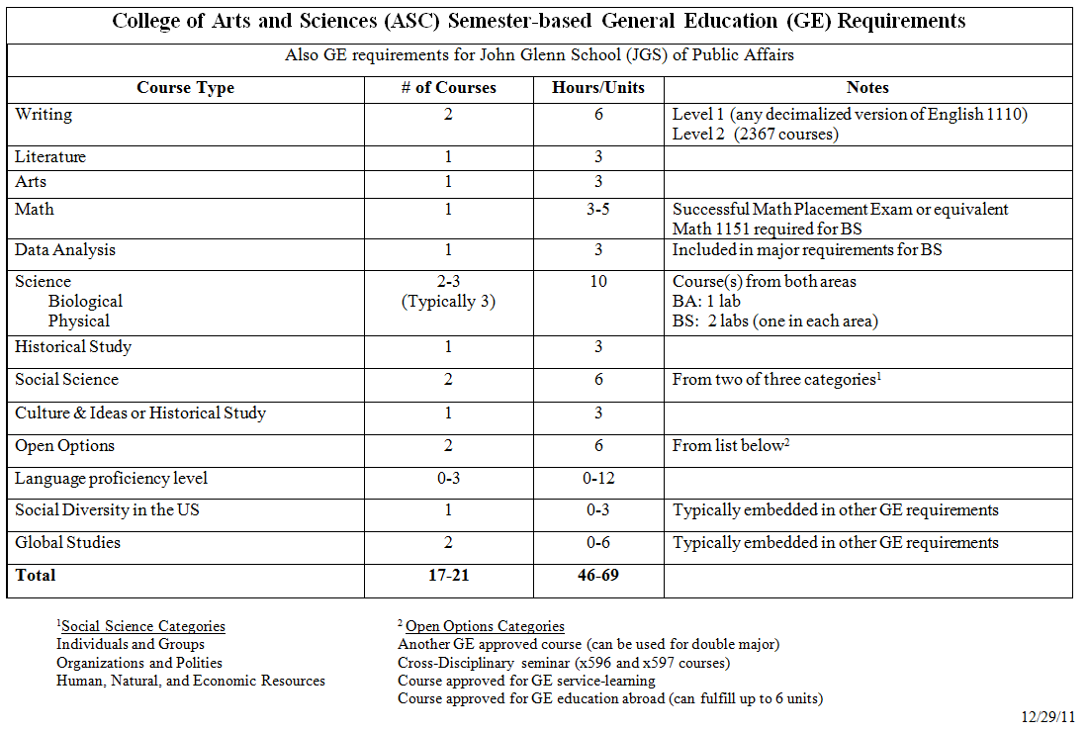

Appendix 4.
Education Abroad approved courses and enrollment numbers; interdisciplinary seminars and enrollment numbers
Open Option course enrollments 2012-13

GE Education Abroad enrollment provided by the Office of International Studies as follows:

GE Education Aboard Course | Enrollment 2012-2013
Honors 2396H | 124
Spanish 2798.11 | 44
Slavic Languages and Literatures 2797.02 | 24
Music 3350 | 22
ASC 2798.03 | 20
History 3798.02 | 18
International Studies 2797.02 | 18
Portuguese 2798.10 | 17
Spanish 2798.12 | 16
Chinese 2797.01 | 9

GE Service Learning – no courses approved for 2012-13

GE Cross-disciplinary seminar enrollment provided by OSU Office of Enrollment Services Analysis and Reporting

College of course offering | GE Cross-Disciplinary Seminar | Enrollment 2012-2013
ASC | COMM 3597.02 | 486
ASC | ECON 4597.01 | 384
SWK | SOCWORK 3597 | 316
ASC | SOCIOL 3597.01 | 303
ASC | ANTHROP 4597.01 | 270
ASC | ANTHROP 4597.02 | 228
AGR | ANIMSCI 4597 | 216
ASC | GEOG 3597.01 | 213
ASC | POLITSC 4597.01 | 200
ASC | THEATRE 3597 | 197
ASC | POLITSC 4597.02 | 148
ENG | CRPLAN 4597 | 115
AGR | AEDECON 4597.01 | 96
ASC | SOCIOL 3597.02 | 95
AGR | PLNTPTH 4597 | 76
AGR | FDSCTE 4597.02 | 60
AGR | FDSCTE 4597.01 | 56
ASC | COMM 3597.01 | 54
ENG | LARCH 3597 | 50
ASC | COMPSTD 4597.02 | 43
ASC | ENGLISH 4597.02 | 40
ASC | ENGLISH 4597.01 | 39
ASC | LING 4597.02 | 32
ASC | INTSTDS 4597.01 | 30
ASC | PORTGSE 4597.01 | 28
ASC | COMPSTD 4597.03 | 28
ASC | COMPSTD 4597.01 | 27
ASC | PORTGSE 4597.02 | 27
ASC | CLAS 4597 | 25
ASC | ANTHROP 4597.05H | 17
AGR | AEDECON 4597.01H | 9
ASC | INTSTDS 4597.01H | 5

Appendix 5.
Quarter and Semester Course Counts

Quarter and Semester Course Counts
GEC Categories (Quarters)  [2011-12 listings] | # of Courses | GE Categories (Semesters) | # of courses as of 1-4-13 | # of courses as of 1-5-14
Writing and Related Skills |  | Writing & Communication
First Writing Course | 5 | Level 1 | 5 | 5
Second Writing Course | 66 | Level 2 | 68 | 69
Third Writing Course | 31
Quantitative and Logical Skills |  | Quantitative Reasoning
Basic Computational Skills | 3 | Basic Computation | 3 | 3
Math and Logical Analysis | 15 | Mathematical or Logical Analysis | 24 | 21
Data Analysis | 25 | Data Analysis | 36 | 32
Natural Science |  | Natural Science
Natural Science: Biological Science | 26 | Biological Science | 34 | 36
Natural Science: Physical Science | 66 | Physical Science | 67 | 67
Arts and Humanities |  | Literature
Literature | 125 | Literature | 131 | 132
 |  | Visual and Performing Arts
Visual and Performing Arts | 90 | Visual and Performing Arts | 101 | 102
Cultures and Ideas | 134
Social Science |  | Social Science
Individuals and Groups | 46 | Individuals and Groups | 48 | 50
Organizations & Polities | 42 | Organizations & Polities | 46 | 46
Human, Natural and Economic Resources | 31 | Human, Natural and Economic Resources | 34 | 34
Historical Study |  | Historical Study
Historical Survey | 40 | Historical Study | 290 | 294
 |  | Cultures and Ideas (or 2nd Historical Study)
 |  | Cultures & Ideas | 161 | 169
Foreign Language Skills |  | Language Proficiency
Foreign Language | 221 | Foreign Language | 187 | 189
Capstone |  | Open Options
Contemporary World | 57 | Cross-Disciplinary Seminar | 53 | 54
 |  | Education Abroad | 2 | 13
 |  | Service Learning | 0 | 4
Diversity |  | Diversity
Social Diversity in the US | 100 | Social Diversity in the US | 123 | 129
International Issues: Western, non-US | 92 | Global Studies | 318 | 343
International Issues: non-Western or Global | 156
Total | 1012 | Total | 1261 | 1290
Totals are less than the sum of all courses because of courses that count in more than one category.

Appendix 6.
GE courses by college

ASC & Non-ASC Courses Contained within the General Education as of May 5, 2013
- Total number of GE courses: 1264
- 92% of all GE courses are in the College of Arts and Sciences.
- 8% of all GE courses are outside of the College of Arts and Sciences.
Number of courses outside of ASC: 95
College | Number of GE Courses
AGR | 44
BUS | 1
EHE | 21
ENG | 16
HRS | 1
NUR | 1
OAA | 2
SWK | 9

Appendix 7.
Course enrollments by GE category

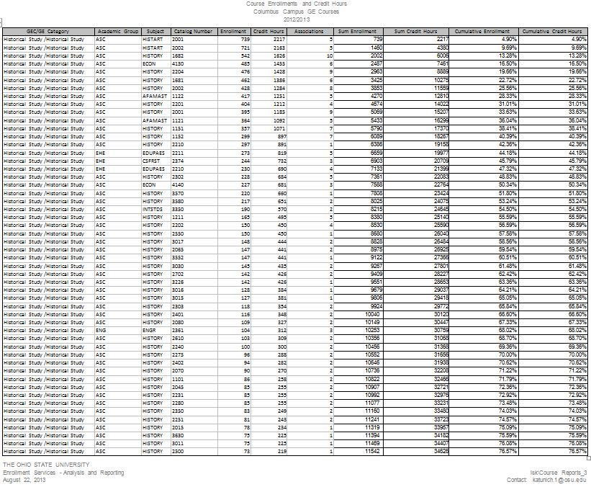

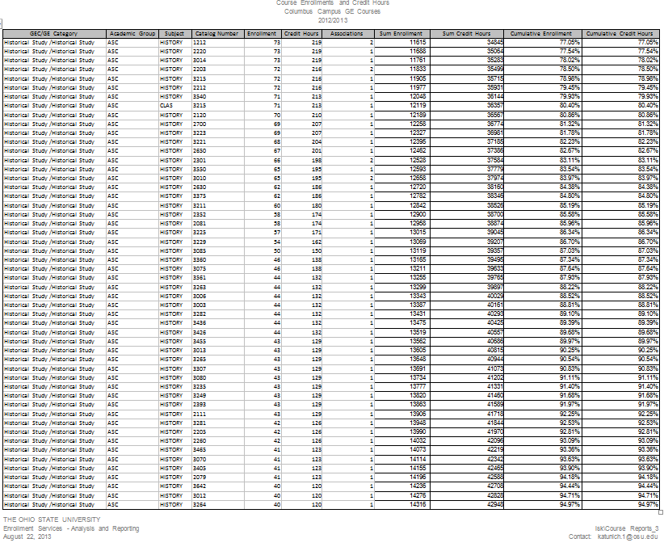

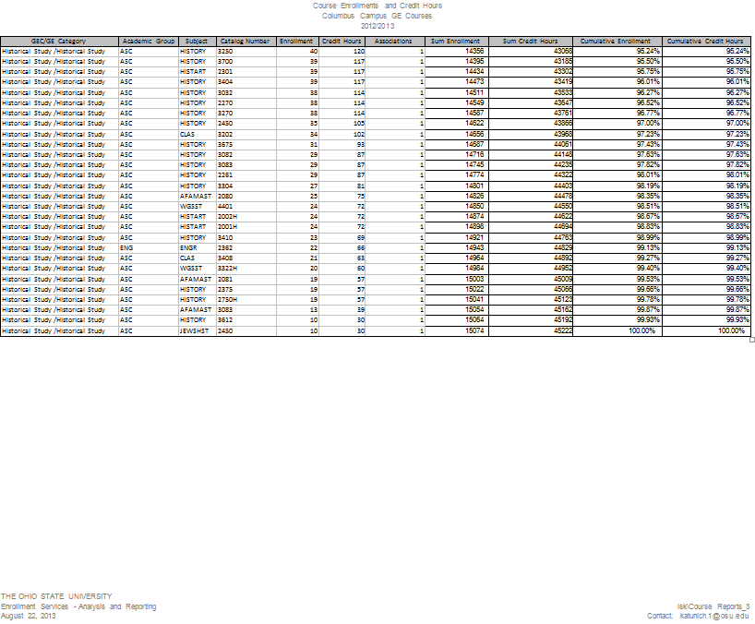

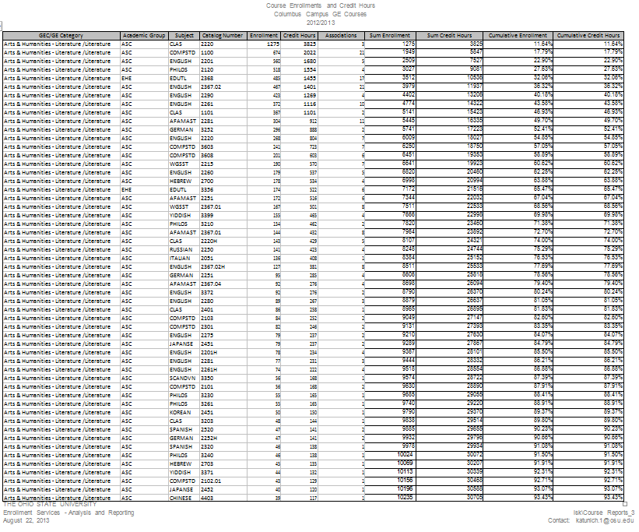

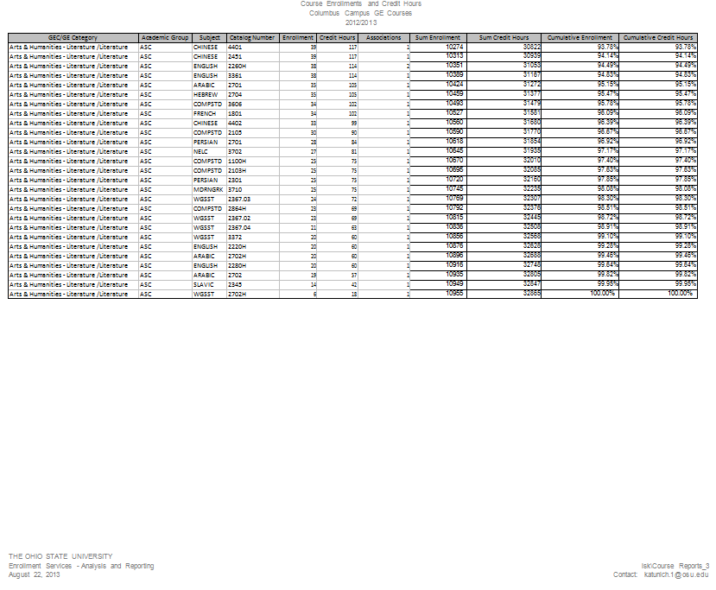

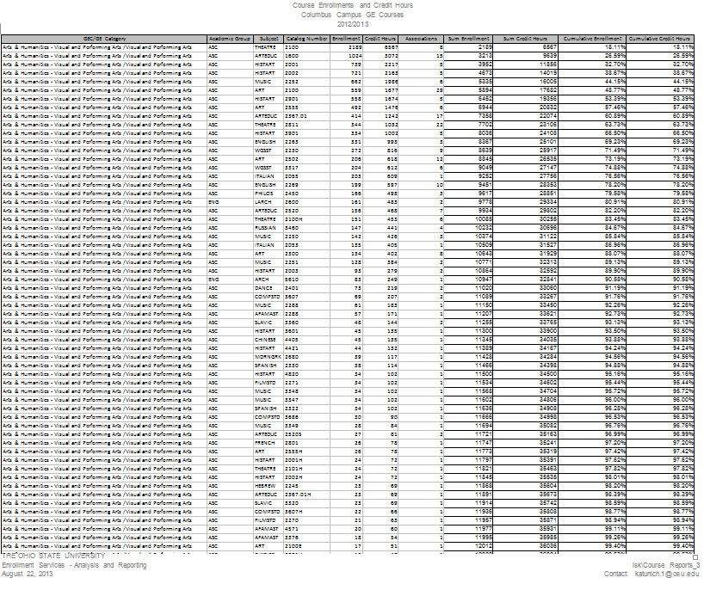

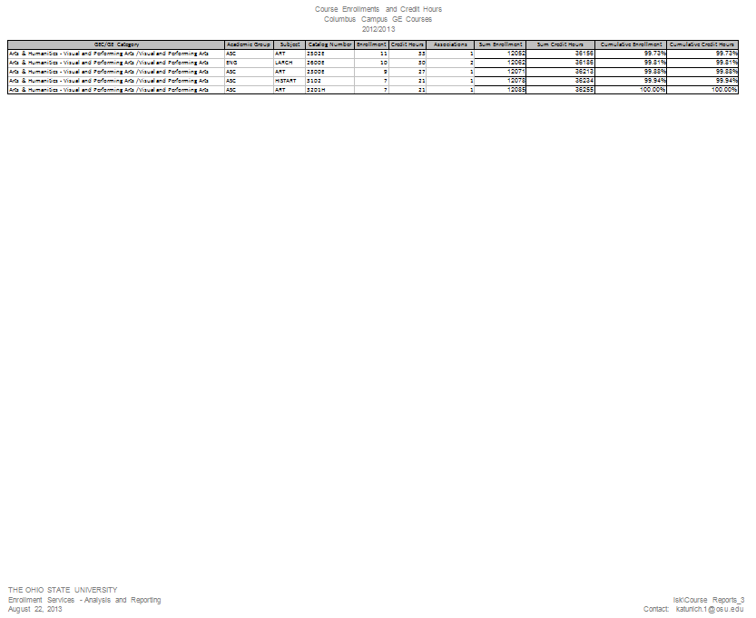

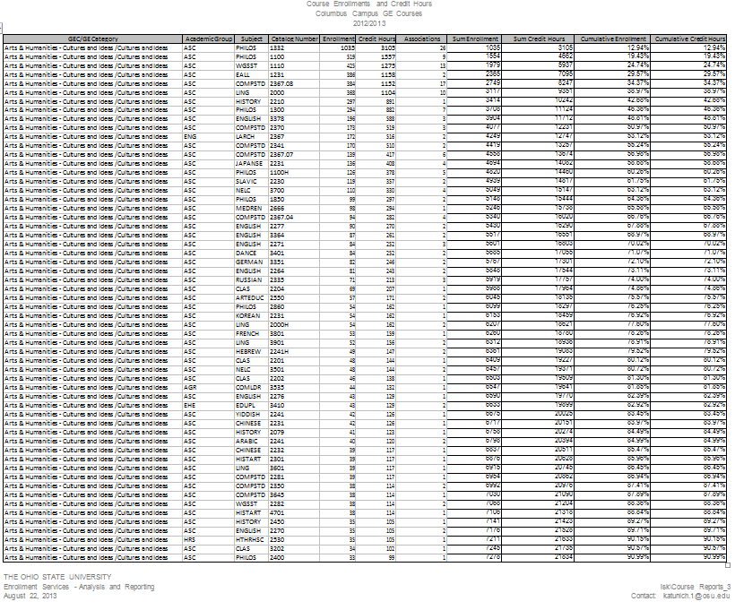

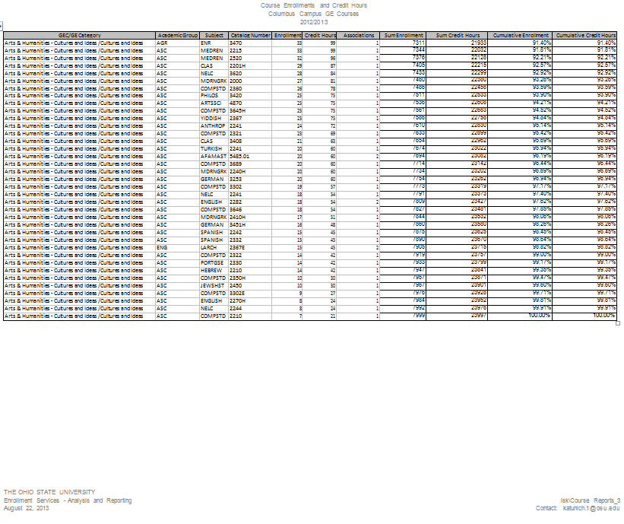

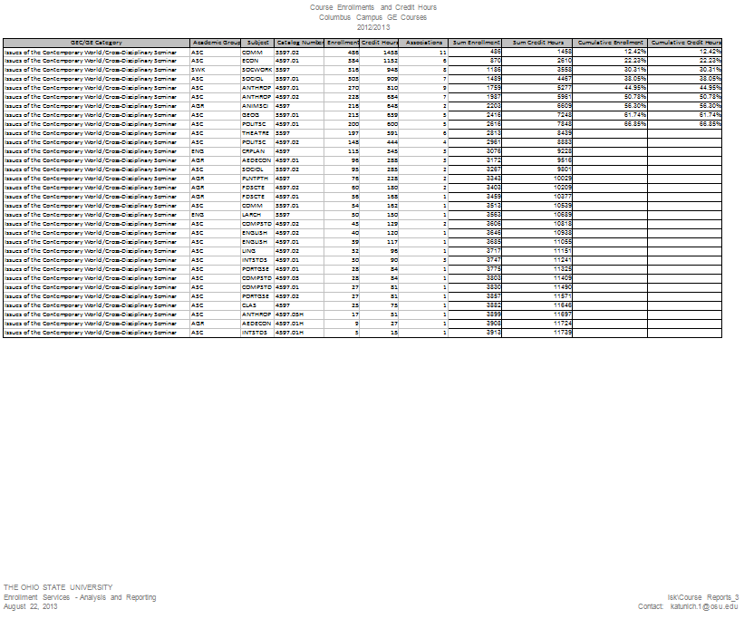

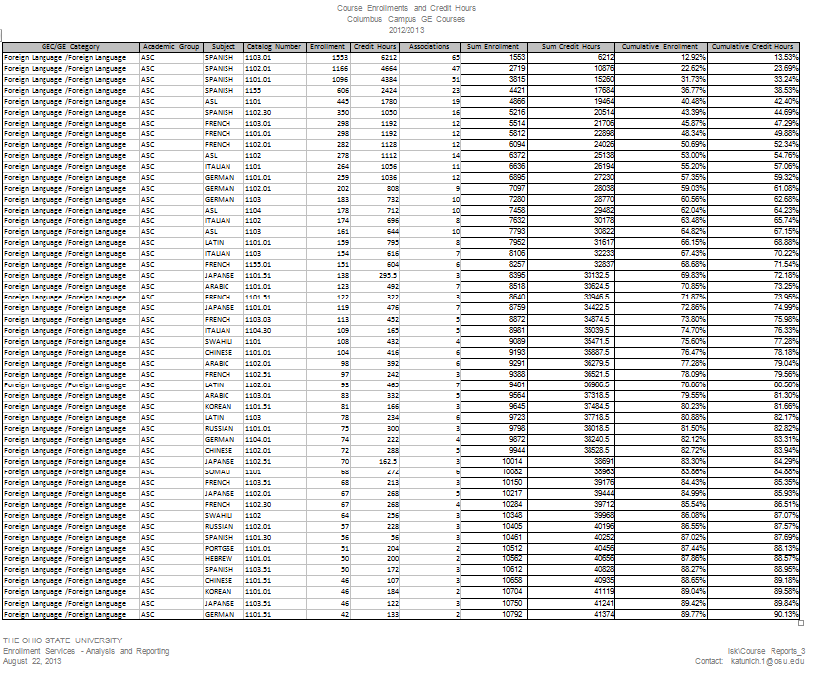

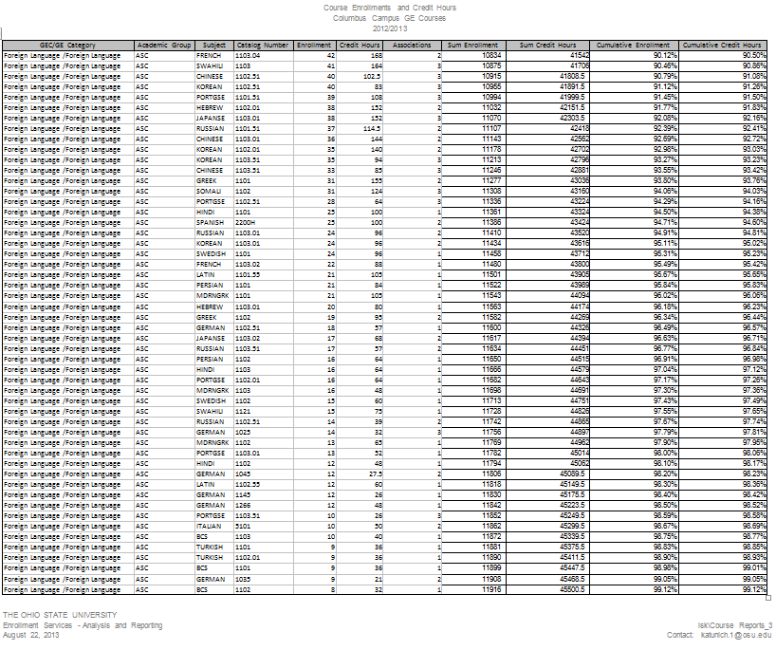

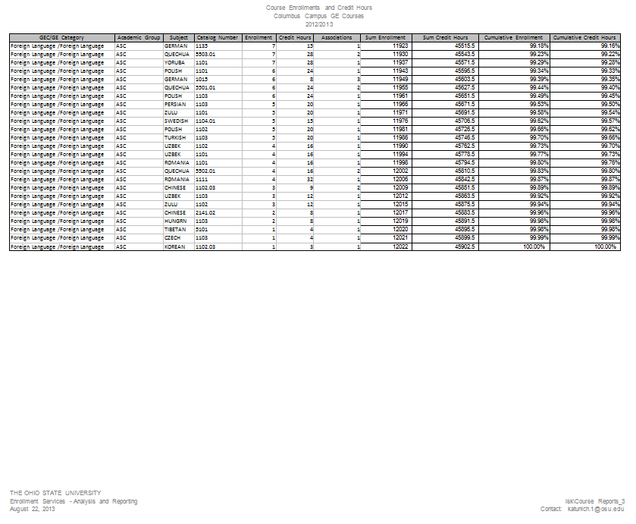

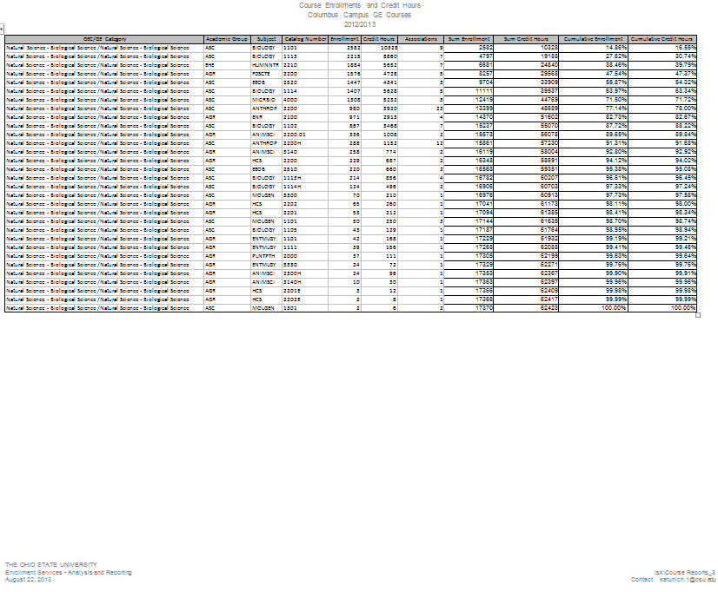

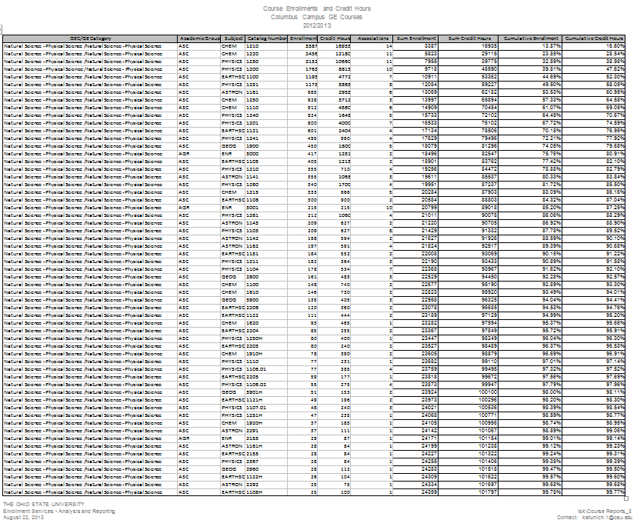

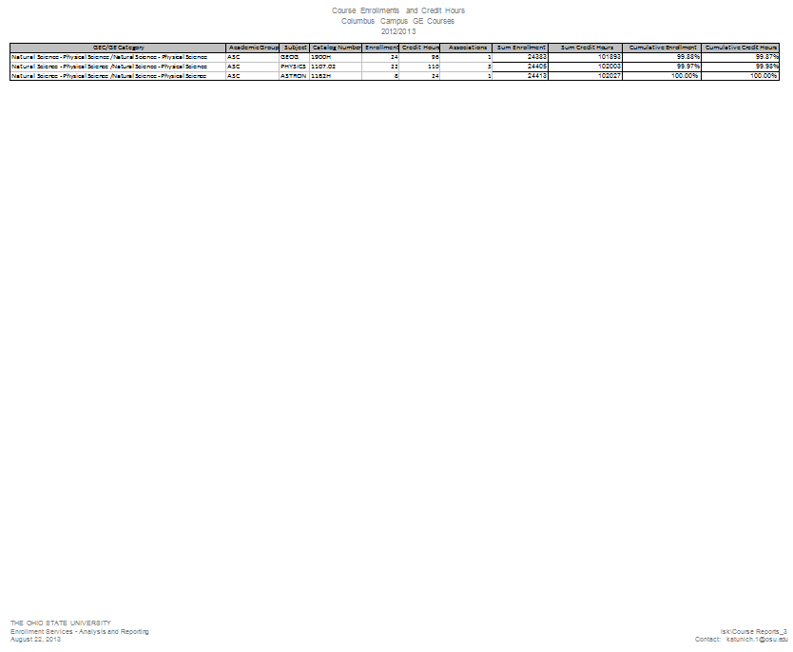

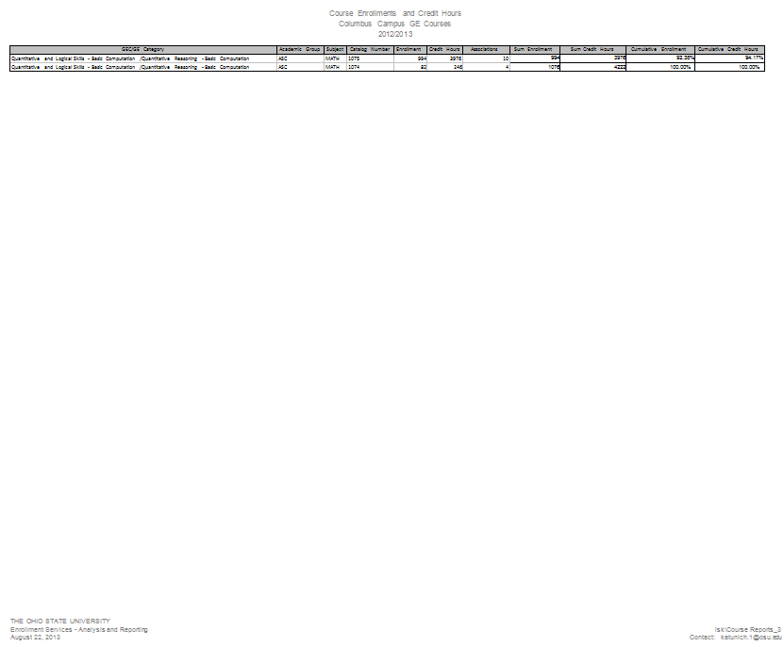

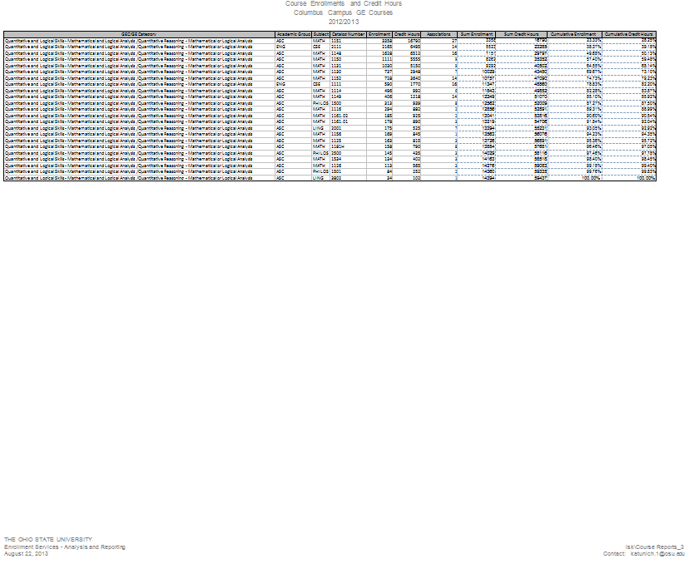

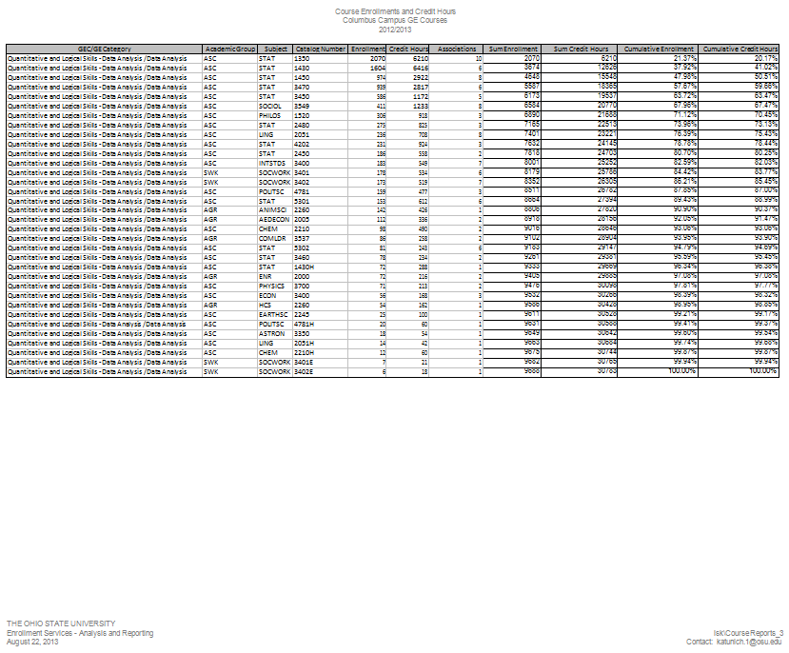

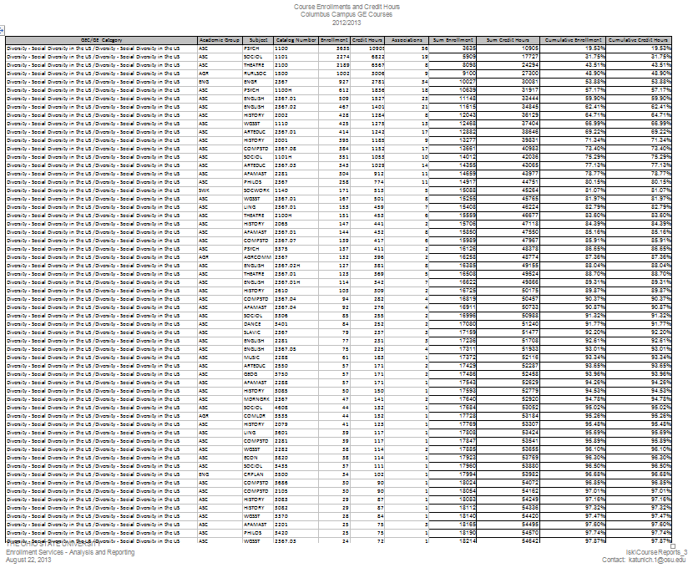

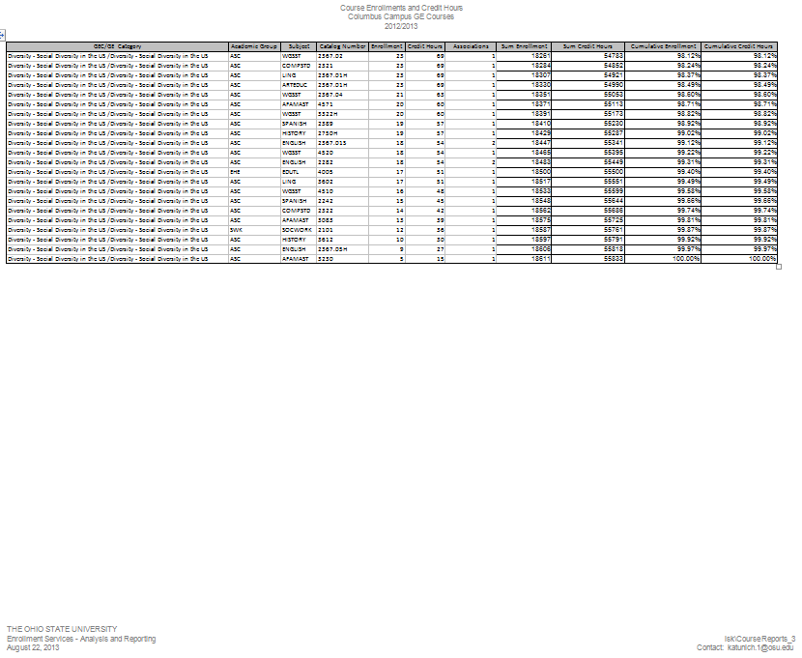

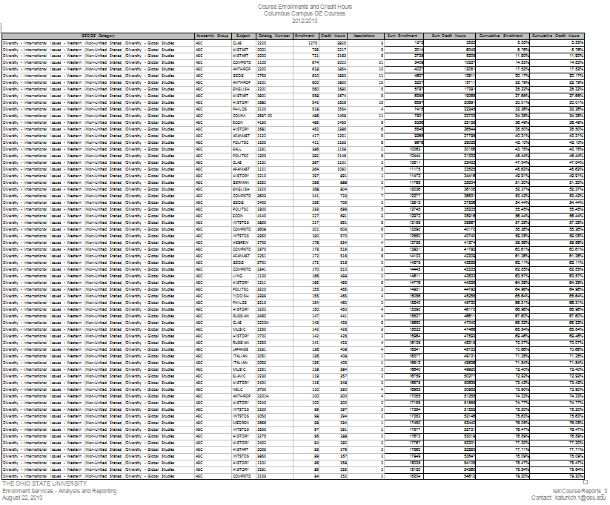

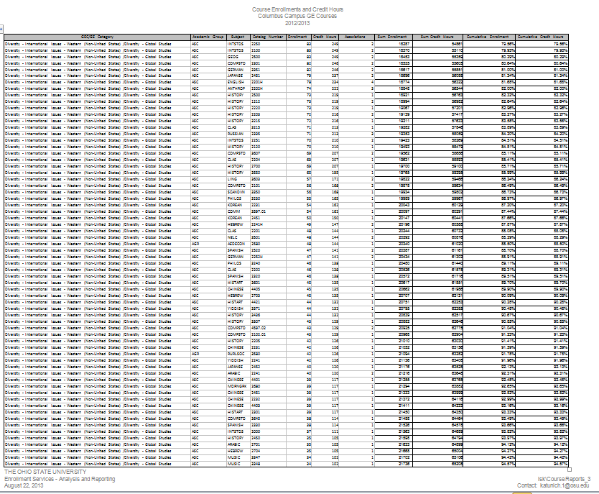

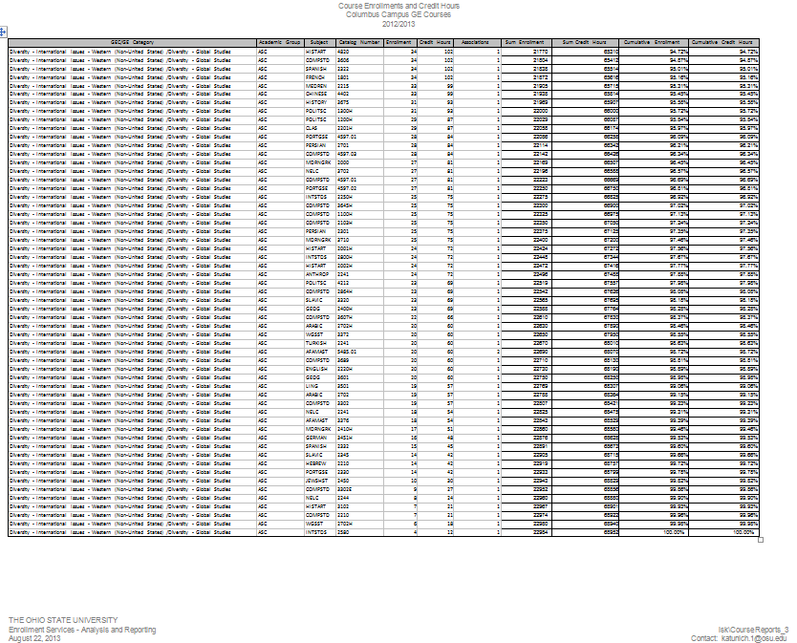

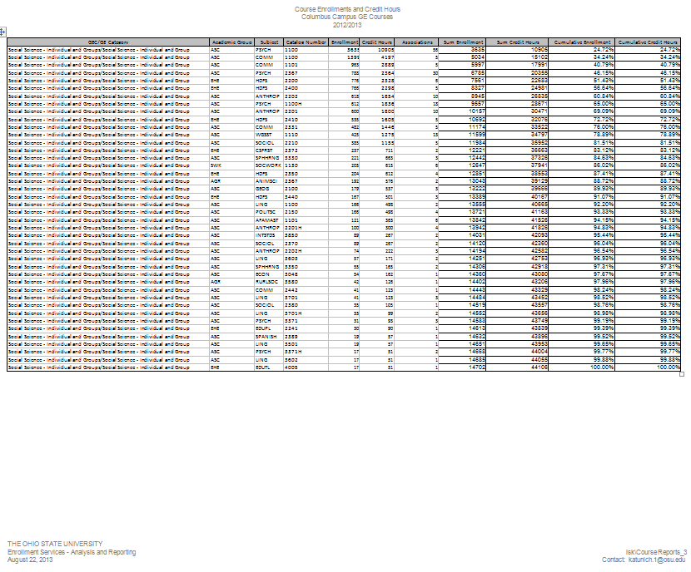

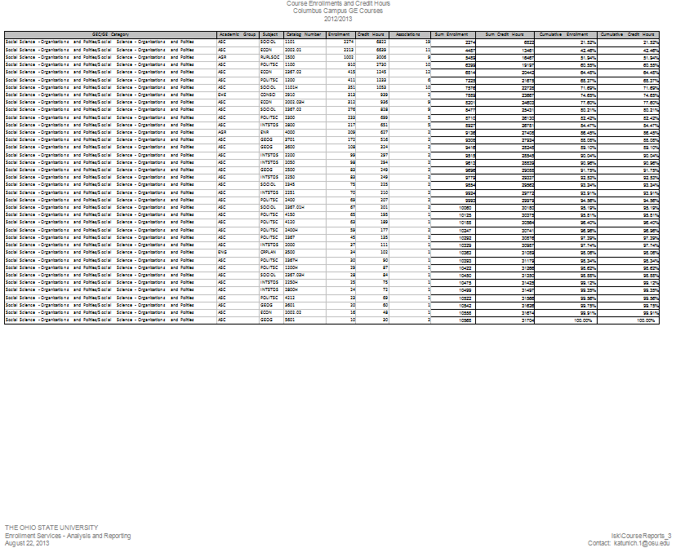

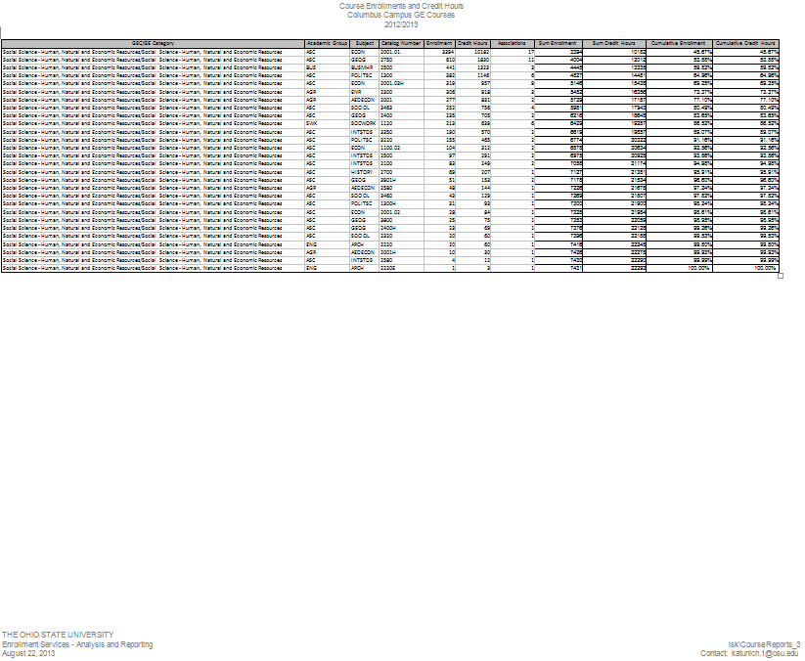

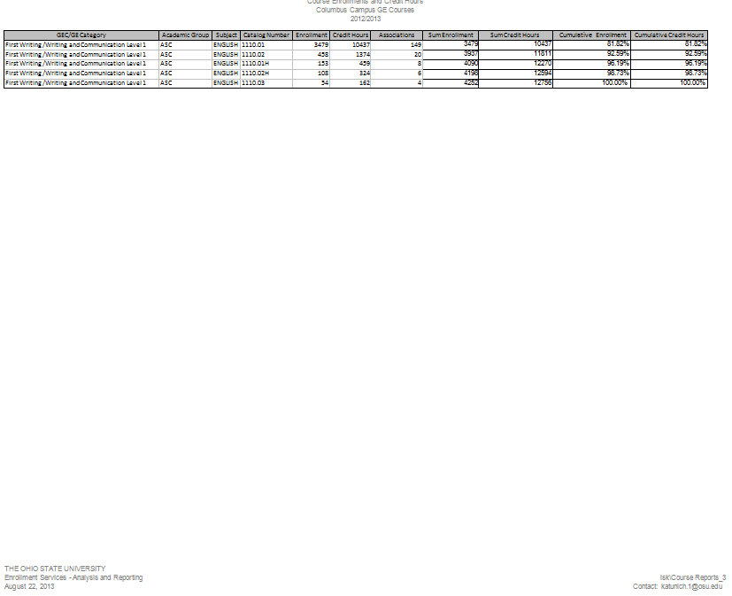

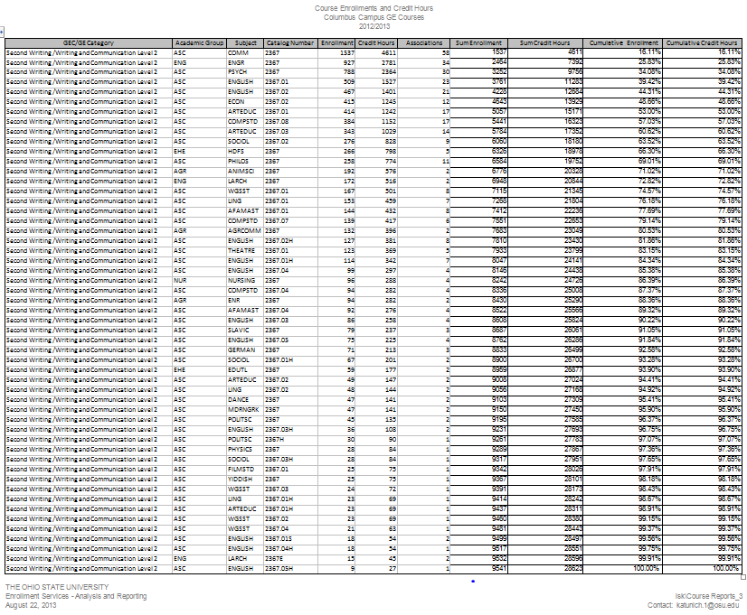

Appendix 8.
Course proposal statistics from Arts and Sciences Curriculum and Assessment Services Office
GE Course Proposal Statistics July 3, 2012 – June 30, 2012

- New Courses with GE Status: 45
- Existing Courses with New GE Category/ies: 27
- GE Courses Withdrawn: 2
- Existing General Education Courses Converted to Semesters: 9
- Changes to GE Courses without GE Category Change: 28
- Removal of University-Wide GE Status: 9

The Ohio State University
ASC Curriculum and Assessment Services
August 28, 2013
Contact: Hogle.12@osu.edu

New Courses with GE Status listed by GE Category: 45
Course Bulletin | Course Number | GE Categories
COMM | 2596 | CROSS-DISC SEM
HONORS | 2596H | CROSS-DISC SEM
CLAS | 3408 | CULT/IDEA | HIST STUDY
GERMAN | 3256 | CULT/IDEA
GERMAN | 3353 | CULT/IDEA
JEWSHST | 2209 | CULT/IDEA
JEWSHST | 2210 | CULT/IDEA | DIV-GLOBAL STUDIES
JEWSHST | 2210H | CULT/IDEA | DIV-GLOBAL STUDIES
JEWSHST | 2241 | CULT/IDEA | DIV-GLOBAL STUDIES
JEWSHST | 2242 | CULT/IDEA | DIV-GLOBAL STUDIES
JEWSHST | 2242H | CULT/IDEA | DIV-GLOBAL STUDIES
MEDREN | 2610 | CULT/IDEA
ARTSSCI | 2797.02 | EDUCATION ABROAD
CHINESE | 2797.01 | EDUCATION ABROAD
HISTORY | 3798.02 | EDUCATION ABROAD | DIV-GLOBAL STUDIES | HIST STUDY
INTSTDS | 2797.02 | EDUCATION ABROAD
MUSIC | 3350 | EDUCATION ABROAD | VPA
PORTGSE | 2798.1 | EDUCATION ABROAD
SLAVIC | 2797.02 | EDUCATION ABROAD | DIV-GLOBAL STUDIES
SPANISH | 2798.11 | EDUCATION ABROAD
SPANISH | 2798.12 | EDUCATION ABROAD
JEWSHST | 3110 | HIST STUDY
CLAS | 2401E | LIT
CLAS | 3407 | LIT | HIST STUDY
EDUTL | 3356E | LIT
JEWSHST | 2700 | LIT | DIV-GLOBAL STUDIES
JEWSHST | 2700H | LIT | DIV-GLOBAL STUDIES
JEWSHST | 2702 | LIT | DIV-GLOBAL STUDIES
JEWSHST | 2702H | LIT | DIV-GLOBAL STUDIES
JEWSHST | 2703 | LIT | DIV-GLOBAL STUDIES
JEWSHST | 2704 | LIT | DIV-GLOBAL STUDIES
JEWSHST | 2708 | LIT | DIV-GLOBAL STUDIES
MEDREN | 2888 | LIT
BIOLOGY | 2100 | NAT SCI-BIO
ANTHROP | 2100.01 | SOC SCI-HNER |  | (Transfer stdnts only)
COMM | 1102H | SOC SCI-IND/GRP
SOCWORK | 1130H | SOC SCI-IND/GRP
HISTART | 2005 | VPA | HIST STUDY
HISTART | 3102 | VPA | DIV-GLOBAL STUDIES
JEWSHST | 2205 | VPA
JEWSHST | 2245 | VPA
MUSIC | 3343 | VPA
ENGR | 2367.01H | WRIT-COMM 2 | SOC DIV-US
JEWSHST | 2367 | WRIT-COMM 2 | CULT/IDEA
PSYCH | 2367.02 | WRIT-COMM 2

Existing Courses with New GE Category/ies listed by Category: 27
Course Bulletin | Course Number | GE Categories |  | Change to GE Status
DANCE | 3402 | CULT/IDEA | DIV-GLOBAL STUDIES
CHINESE | 2141.01 | FOREIGN LANG
JAPANSE | 2141 | FOREIGN LANG
HISTORY | 2251 | HIST STUDY | DIV-GLOBAL STUDIES | Added "DIV-GLOBAL STUDIES"
HISTORY | 2280 | HIST STUDY | DIV-GLOBAL STUDIES | Added "DIV-GLOBAL STUDIES"
HISTORY | 2375 | HIST STUDY | DIV-GLOBAL STUDIES | Added "DIV-GLOBAL STUDIES"
HISTORY | 2550 | HIST STUDY | DIV-GLOBAL STUDIES | Added "DIV-GLOBAL STUDIES"
HISTORY | 2650 | HIST STUDY | DIV-GLOBAL STUDIES | Added "DIV-GLOBAL STUDIES"
HISTORY | 3014 | HIST STUDY | SOC DIV-US | Added "SOC DIV-US"
HISTORY | 3075 | HIST STUDY | SOC DIV-US | Added "SOC DIV-US"
HISTORY | 3106 | HIST STUDY | DIV-GLOBAL STUDIES | Added "DIV-GLOBAL STUDIES"
HISTORY | 3216 | HIST STUDY | DIV-GLOBAL STUDIES | Added "DIV-GLOBAL STUDIES"
HISTORY | 3221 | HIST STUDY | DIV-GLOBAL STUDIES | Added "DIV-GLOBAL STUDIES"
HISTORY | 3229 | HIST STUDY | DIV-GLOBAL STUDIES | Added "DIV-GLOBAL STUDIES"
HISTORY | 3281 | HIST STUDY | DIV-GLOBAL STUDIES | Added "DIV-GLOBAL STUDIES"
HISTORY | 3282 | HIST STUDY | DIV-GLOBAL STUDIES | Added "DIV-GLOBAL STUDIES"

HISTORY | 3375 | HIST STUDY | DIV-GLOBAL STUDIES | Added "DIV-GLOBAL STUDIES"
HISTORY | 3570 | HIST STUDY | DIV-GLOBAL STUDIES | Added "DIV-GLOBAL STUDIES"
HISTORY | 3580 | HIST STUDY | DIV-GLOBAL STUDIES | Added "DIV-GLOBAL STUDIES"
HISTORY | 3715 | HIST STUDY | DIV-GLOBAL STUDIES | Added "DIV-GLOBAL STUDIES"
CHINESE | 4404 | LIT | DIV-GLOBAL STUDIES | Course used to have double GE status under quarters; was inadvertently not requested during conversion
ENGLISH | 4567S | SERVICE LEARNING
GEOG | 5200S | SERVICE LEARNING
SOCIOL | 2211S | SERVICE LEARNING
SOCIOL | 2320 | SOC SCI-HNER
AFAMAST | 3376 | VPA | DIV-GLOBAL STUDIES | Removed “SOC DIV-US” and added DIV-GLOBAL STUDIES
HISTART | 3631 | VPA | SOC DIV-US

GE Courses Withdrawn: 2
Course Bulletin | Course Number | GE Categories
SPANISH | 1101.51 | FOREIGN LANG
HISTART | 2367 | WRIT-COMM 2 | VPA

Existing General Education Courses Converted to Semesters: 9
Course  Bulletin | Course  Number | Type of conversion
AFAMAST | 3304 | Semester equivalent of a quarter course: GE Historical Study
ENGLISH | 2202 | Semester equivalent of a quarter course: GE Literature & GE Diversity—Global Studies
ENGLISH | 2202H | Semester equivalent of a quarter course: GE Literature & GE Diversity—Global Studies
ENGLISH | 2291 | Semester equivalent of a quarter course: GE Literature
ENTOMOLOGY | 2101 | Modified/Re-envisioned: Approved for GE Natural Science-Biological Science
NELC | 4597 | Semester equivalent of a quarter course: GE Cross-Disciplinary Seminar
SLAVIC | 4597 | Modified/Re-envisioned: GE Global Studies added to existing GE Cross-Disciplinary Seminar
ROMANIA | 1111 | Semester equivalent of a quarter course: GE Foreign Language
SOCIOL | 1101E | Semester equivalent of a quarter course: GE Social Science-Organizations and Polities & GE Social Diversity in the US

Changes to GE Courses without Category Change: 28
Course Bulletin | Course Number | GE Categories |  |  | Change
ESEPHL | 3410 | CULT/IDEA |  |  | Changed course listing from EDUPL
HISTART | 2301 | CULT/IDEA | DIV-GLOBAL STUDIES | HIST STUDY | Changed course number (from 3301)
HTHRHSC | 2530 | CULT/IDEA |  |  | Changed course listing from ALLIMED
GERMAN | 1135 | FOREIGN LANG |  |  | Changed course number (from 1035)
GERMAN | 1145 | FOREIGN LANG |  |  | Changed course number (from 1045)
HISTORY | 2641 | HIST STUDY | DIV-GLOBAL STUDIES |  | Changed course number (from 1681)
HISTORY | 2642 | HIST STUDY | DIV-GLOBAL STUDIES |  | Changed course number (from 1682)
HISTORY | 3276 | HIST STUDY |  |  | Changed course number (from 2260)
WGSST | 2750H | HIST STUDY | SOC DIV-US |  | Changed course number (from 3322H)
ENGLISH | 2201 | LIT | DIV-GLOBAL STUDIES |  | Content reverting to pre- conversion format: “Medieval through 1800”
ENGLISH | 2201H | LIT | DIV-GLOBAL STUDIES |  | Content reverting to pre- conversion format: “Medieval through 1800”

ENGLISH | 2290 | LIT |  |  | Content reverting to pre- conversion format: “Colonial and US Literature to 1865”
GERMAN | 3252 | LIT | DIV-GLOBAL STUDIES |  | Uncrosslisted from Yiddish 3399. This course will focus on "The Holocaust in  German Literature and
YIDDISH | 3399 | LIT | DIV-GLOBAL STUDIES |  | Uncrosslisted from German 3352. This course will focus on "The  Holocaust in Yiddish and
ASTRON | 1140 | NAT SCI-PHYS |  |  | Changed course number (from 1161)
ASTRON | 1144 | NAT SCI-PHYS |  |  | Changed course number (from 1162)
ASTRON | 2161H | NAT SCI-PHYS |  |  | Changed course number (from 1161H)
ASTRON | 2162H | NAT SCI-PHYS |  |  | Changed course number (from 1162H)
MATH | 1074 | QUAN-BAS COMP |  |  | No longer live course. Only for transfer students.
MATH | 1534 | QUAN-MATH/LA |  |  | No longer live course. Only for transfer students.
ESCFE | 1201 | SOC DIV-US |  |  | Changed course listing from EDUPL
ESCFE | 1202 | SOC DIV-US |  |  | Changed course listing from EDUPL
COMM | 3442 | SOC SCI-IND/GRP |  |  | Changed course number (from 2442) and added more in-depth material.

ESCFE | 2241 | SOC SCI-IND/GRP |  |  | Changed course listing from EDUPL
SOCIOL | 3380 | SOC SCI-IND/GRP |  |  | Changed course number (from 2380)
PSYCH | 2367.01 | WRIT-COMM 2 | SOC SCI-IND/GRP |  | Changed course number (from 2367)
KNSISM | 2210 |  |  |  | Changed course listing from EDUPAES
KNSISM | 2211 |  |  |  | Changed course listing from EDUPAES

Removal of University-Wide GE Status listed by GE Category: 9
Course Bulletin | Course Number | GE Categories
PSYCH | 4597.02 | CROSS-DISC SEM
SOCWORK | 3401 | DATA ANLS
SOCWORK | 3401E | DATA ANLS
SOCWORK | 3402 | DATA ANLS
SOCWORK | 3402E | DATA ANLS
MATH | 1125 | QUAN-MATH/LA
MATH | 1126 | QUAN-MATH/LA
KOREAN | 5405 | VPA
ARCH | 5610 | VPA

Appendix 9.
NSSE data

