College of Arts and Sciences

Office of the Associate

and Assistant Deans

114 University Hall

230 North Oval Mall

Columbus, OH 43210

614-292-1667 Phone

asc.osu.edu

January 19th, 2024

W. Randy Smith, Vice Provost

Council on Academic Affairs

Bricker Hall

CAMPUS

Dear Randy:

On January 19th I gave an overview of the proposal to offer a BA degree in WGSS at the Ohio Reformatory for Women to the Arts and Sciences Curriculum Committee This prison education program aligns with the mission of the College of Arts and Sciences and was enthusiastically supported by the curriculum committee. The leads of the program will give a more in-depth update to the Curriculum Committee later this semester, and they have also met with college leadership, including the director of advising and the division dean for the Arts and Humanities to discuss the logistics of the program. It has the full support of the College of Arts and Sciences.

Sincerely,

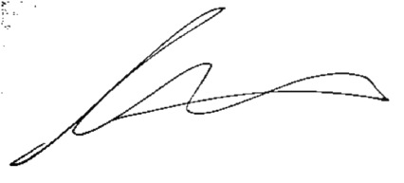

Andrew W. Martin

Associate Dean for Undergraduate Education

Professor, Department of Sociology