

## College of Nursing

## Jane E. Heminger Hall

1577 Neil Ave

Columbus, OH 43210

## Phone (614) 292-8900

E-mail nursing@osu.edu

Web nursing.osu.edu

October 11, 2024

Dr. W. Randy Smith

Vice Provost for Academic Programs

University Square South

15 E. 15th Avenue

Columbus, OH 43201

Dear Vice Provost Smith and Members of the Committee on Academic Affairs:

The College of Nursing will be pausing out Bachelor of Science in Health and Wellness program for the 2025-2026 and 2026-2027 academic years. The rationale for this pause is as follows:

(1) the program has had consistent low enrollment

(2) only 3 students are admitted to the major for autumn 2024

(3) when students are admitted to health and wellness program, it is usually students who applied to nursing and did not get in then decide to re-apply to nursing the following year and leave the health and wellness program for nursing

We plan to update our website and promotional materials immediately, reflecting this change. Please let us know if there are any questions or concerns.

Thank you for your consideration of this request,

Sincerely,

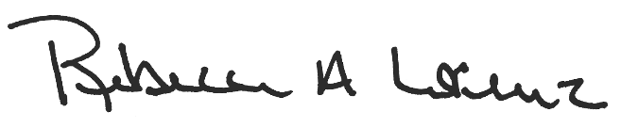

Rebecca Lorenz, PhD, RN

Associate Professor

Senior Associate Dean for Academic Affairs and Educational Innovation

Copy:

• Dr. Wendy Bowles, Associate Dean for Baccalaureate Programs

• Dr. Karen Rose, Dean